Lab 1

1:write program to test Hello World.
#include<bits/stdc++.h> using namespace std; int main(int argc, char const *argv[])
{ cout<<"Hello World!"<<endl;
return 0;
}

2:Write a program to adddition of two numbers .
#include<bits/stdc++.h> using namespace std;

int main(int argc, char const *argv[])
{ double num1,num2; cout<<"Enter the two numbers: "<<endl; cin>>num1>>num2; cout<<"Sum of given numbers is "<<num1+num2<<endl;
return 0;
}
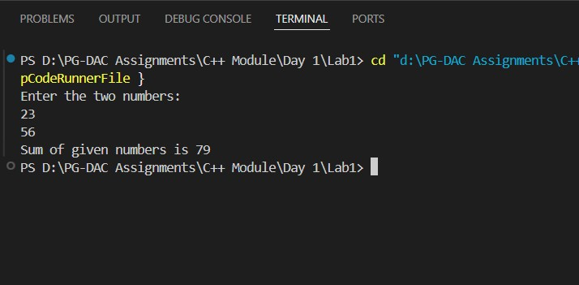
3:Write a program to swap two numbers.
#include<bits/stdc++.h> using namespace std;

void swap(int &num1,int &num2)
{ int temp = num1; num1 =num2; num2 = temp;
}

int main(int argc, char const *argv[])
{ int num1,num2; cout<<"Enter two integers: "<<endl; cin>>num1>>num2; cout<<"Numbers Before swapping: num1= "<<num1<<" and num= "<<num2<<endl; swap(num1,num2); cout<<"Numbers after swapping: num1= "<<num1<<" and num= "<<num2<<endl;
return 0;
}
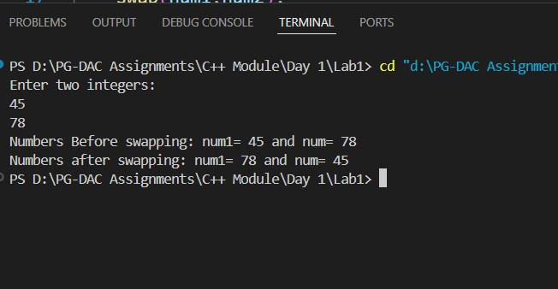
4. Write a program to accept an integer and check if it is even or odd.
//Tell the number is even or odd #include<bits/stdc++.h> using namespace std;

int main(int argc, char const *argv[])
{ int num; cout<<"Enter the number: "<<endl; cin>>num;

if(num % 2== 0)
{
cout<<num<<" is Even. "<<endl;
} else
{
cout<<num<<" is odd "<<endl;
} return 0;
}
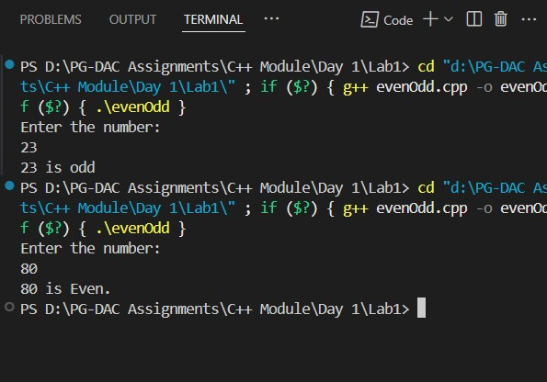
- Write a program to accept a number and check if it is divisible by 5 and 7. #include <iostream> using namespace std;

int main() {
int n;
cout << "Enter a number: "; cin >> n;

if (n % 5 == 0 && n % 7 == 0) cout << n << " is divisible by both 5 and 7"; else cout << n << " is not divisible by both 5 and 7";

return 0;
}
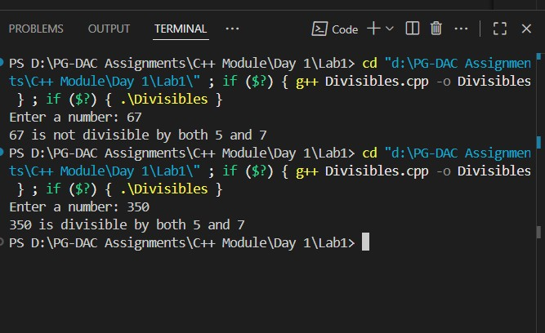
- Write a program, which accepts annual basic salary of an employee and calculates and displays the
Income tax as per the following rules.
Basic: < 1, 50,000 Tax = 0
1, 50,000 to 3,00,000 Tax = 20%
> 3,00,000 Tax = 30% #include <iostream> using namespace std;

int main() { double basicSalary, tax = 0; cout << "Enter Annual Basic Salary: "; cin >> basicSalary;

if (basicSalary < 150000) {
tax = 0;
}
else if (basicSalary <= 300000) { tax = 0.20 * (basicSalary - 150000); } else { tax = 0.20 * 150000 + 0.30 * (basicSalary - 300000);
}

cout << "Income Tax = Rs. " << tax << endl;

return 0;
}
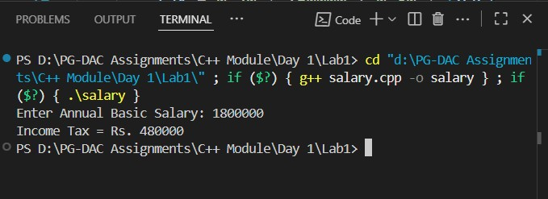
7. Accept a lowercase character from the user and check whether the character is a vowel or consonant.
(Hint: a, e, i, o, u are vowels) #include <iostream> using namespace std;

int main() { char ch; cout << "Enter a lowercase character: "; cin >> ch;

if (ch >= 'a' && ch <= 'z') { if (ch == 'a' || ch == 'e' || ch == 'i' || ch == 'o' || ch == 'u') cout << ch << " is a vowel";
else cout << ch << " is a consonant"; } else { cout << "Invalid input! Please enter a lowercase letter.";
}

return 0;
}
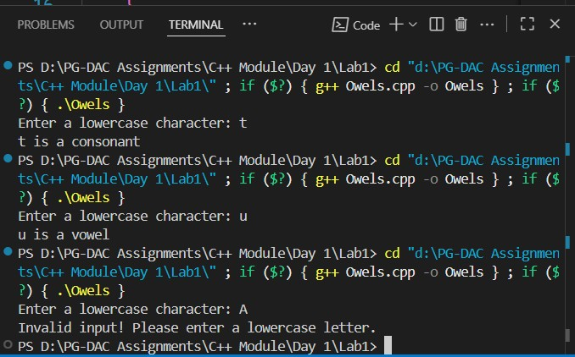
8. Write a program to input angles of a triangle and check whether triangle is valid or not. #include <iostream> using namespace std;

int main() {
int a, b, c; cout << "Enter three angles of the triangle: "; cin >> a >> b >> c;

if (a > 0 && b > 0 && c > 0 && (a + b + c == 180)) cout << "The triangle is valid" << endl; else cout << "The triangle is not valid" << endl;

return 0;
}
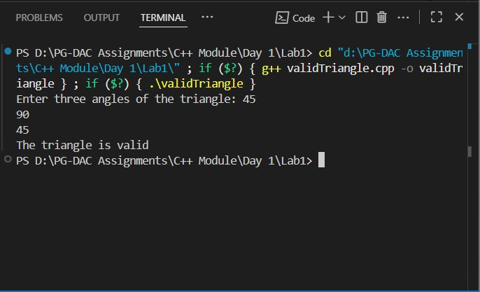
9:Write a program to find factorial of a given number. ex:no5 fact=5*4*3*2*1=120
//Write a program to find factorial of a given number. ex:no5 fact=5*4*3*2*1=120

#include<bits/stdc++.h> using namespace std;

int main(int argc, char const *argv[])
{ int num,fact = 1; cout<<"Enter the +ve Integer: "<<endl; cin>>num; if(num <= 0) return 1;

for(int i = 1; i<=num;i++) fact*=i;
cout<<"The factorial of "<<num<<" is "<<fact<<endl;
return 0;
}
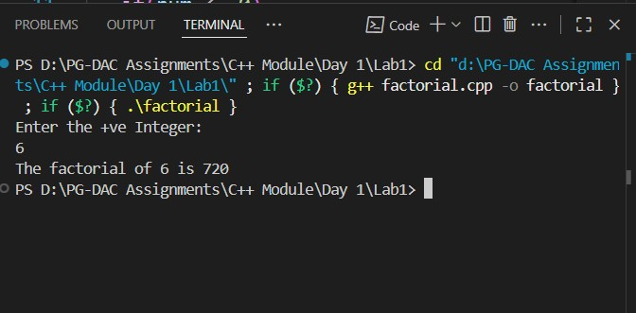
10:Write a program to find m to the power n. m=3 and n=4 so 3*3*3*3
#include <bits/stdc++.h> using namespace std;

int main(int argc, char const *argv[])
{ int num, pw; cout << "Enter the number and power" << endl; cin >> num >> pw; if (num <= 0)
{
cout << "Enter +ve integer only" << endl;
return 0;
}

cout << num << "to the power " << pw << " is " << pow(num,pw) << endl;
return 0;
}
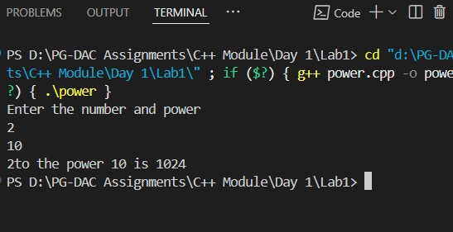
11:Check if number is a prime number or not.:
#include <bits/stdc++.h> using namespace std;

bool isPrime(int num) { if (num <= 1) return false;

for (int i = 2; i <= sqrt(num); i++) { if (num % i == 0) return false;
} return true;
}

int main() { int num; cout << "Enter the Number: "; cin >> num;

if (isPrime(num)) { cout << "The number is Prime" << endl;
} else { cout << "The number is not Prime" << endl; }

return 0;
}
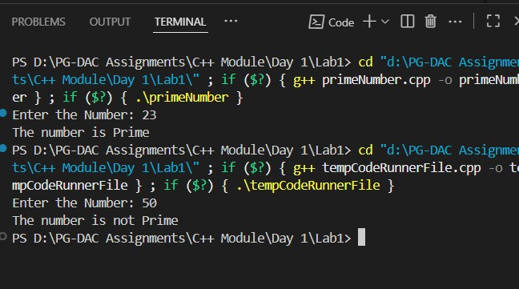

12:Sum of series :
1+2+3+….+n
13:Check whether the number is palindrome or not?
#include <iostream> using namespace std;

int main() { int num, org, rev = 0, rem;

cout << "Enter a number: "; cin >> num;

org = num; // store original number

while (num > 0) { rem = num % 10; rev = rev * 10 + rem; num = num / 10;
}

if (org == rev) { cout << org << " is a Palindrome number." << endl;
} else { cout << org << " is NOT a Palindrome number." << endl;
}

return 0;
}
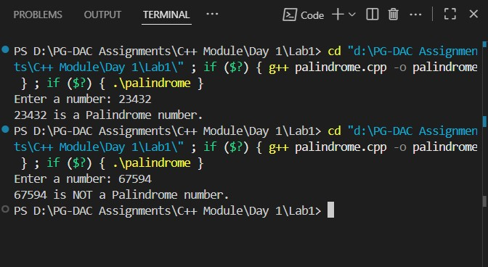

14:Write a program to find sum of all even and odd numbers between 1 to n.
#include<bits/stdc++.h> using namespace std;

int main(int argc, char const *argv[])
{ int num,evenSum = 0,oddSum = 0; cout<<"Enter the number: "<<endl; cin>>num; if(num <0)
{
cout<<"Enter the +ve number only"<<endl;
return 0;
} for(int i = 1; i<num;i++)
{ if(i%2 == 0){ evenSum += i;
}else
{
oddSum += i;
}
}
cout<<"Sum of all Even Numbers between 1 to "<<num<<" is "<<evenSum<<endl; cout<<"Sum of all Odd Numbers between 1 to "<<num<<" is "<<oddSum<<endl;
return 0;
}
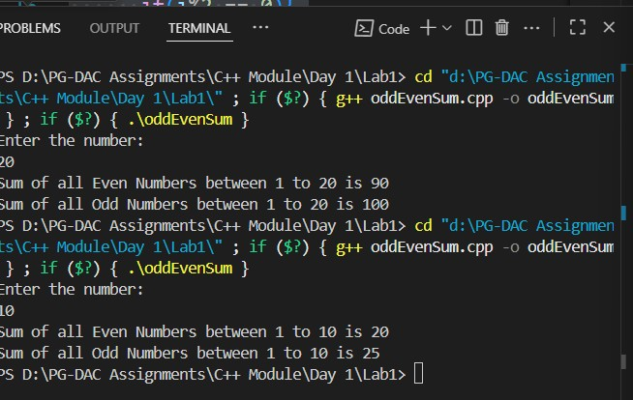
15: Write a program to enter a number and print its reverse.
#include<bits/stdc++.h> using namespace std;

int main(int argc, char const *argv[])
{ int num,temp,org,rev=0; cout<<"Enter the number: "<<endl; cin>>num; org =num; while (num > 0) { temp = num % 10; rev = rev * 10 + temp; num = num / 10;
}
cout<<"Reverse of the "<<org<<" is "<<rev<<endl;
return 0;
}
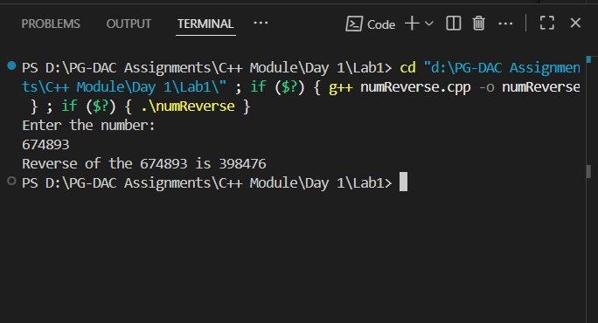
16:Write a program to print all Prime numbers between 1 to n.

#include<bits/stdc++.h> using namespace std;

int main(int argc, char const *argv[])
{ int num; cout<<"Enter the number: "<<endl; cin>>num; if(num <= 1)
{
cout<<"Not a Prime Number!"<<endl;
return 0;
}

for(int i = 2;i<=num;i++)
{ int flag=0; for(int j = 2;j <=i/2;j++) { if(i%j==0){ flag=1; break;
}
} if(flag==0)
{
cout<<i<<endl;
}
}

return 0;
}
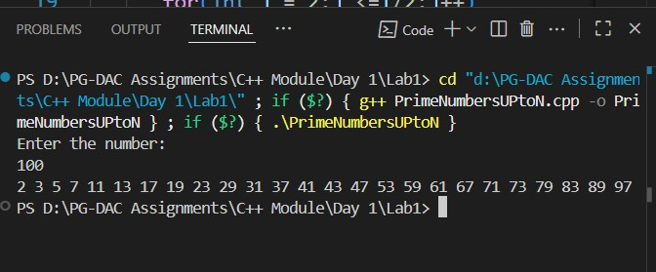
17:Write a program to check entered number is Armstrong number or not.
#include <bits/stdc++.h> using namespace std;

int main() { int num; cout << "Enter the number: "; cin >> num;

int org = num; int cnt = 0; int temp = num;

while (temp != 0) { cnt++; temp /= 10;
}

long long result = 0; temp = num;

while (temp != 0) { int digit = temp % 10; result += (int)round(pow(digit, cnt)); temp /= 10;
}

if (result == org) { cout << org << " is an Armstrong Number" << endl;
} else { cout << org << " is not an Armstrong Number" << endl;
}

return 0;
}

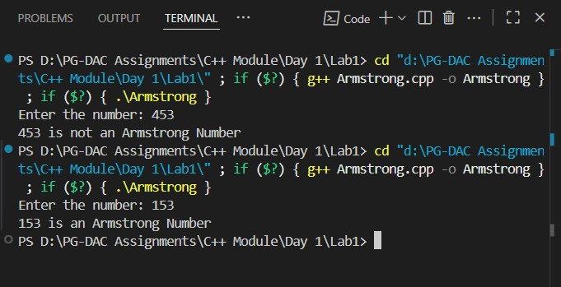
18:Write a program to find greatest of three numbers using nested if-else.
#include <iostream> using namespace std;

int main() {
int a, b, c;
cout<<"Enter 3 numbers one by one: "<<endl; cin >> a >> b >> c;

if (a >= b) { if (a >= c) cout <<"Largerst Number is: "<< a;
else
cout <<"Largerst Number is: "<<c;
} else { if (b >= c) cout <<"Largerst Number is: "<< b;
else
cout <<"Largerst Number is: "<< c;
}

return 0;
}

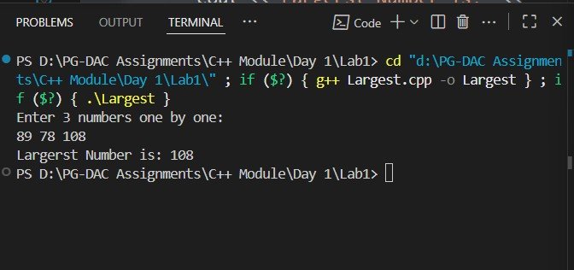
19:Create menu driven program for Pizza Shop.And display total amount,
#include <iostream> using namespace std;

int main() { int choice, qty; int total = 0; char ch;

do { cout << "\n---- Pizza Shop Menu ----\n"; cout << "1. Margherita - Rs. 200\n"; cout << "2. Farmhouse - Rs. 300\n"; cout << "3. Peppy Paneer - Rs. 250\n"; cout << "4. Veggie Paradise - Rs. 280\n"; cout << "5. Exit\n"; cout << "Enter your choice: "; cin >> choice;

if (choice >= 1 && choice <= 4) { cout << "Enter quantity: "; cin >> qty;
}

switch (choice) { case 1: total += 200 * qty; break; case 2: total += 300 * qty; break; case 3: total += 250 * qty; break; case 4: total += 280 * qty; break; case 5: cout << "Exiting...\n"; break; default: cout << "Invalid choice!\n"; break;
}

if (choice != 5) { cout << "Do you want to order more? (y/n): "; cin >> ch; } else { ch = 'n';
}

} while (ch == 'y' || ch == 'Y');

cout << "\nTotal Amount = Rs. " << total << endl;

return 0;
}
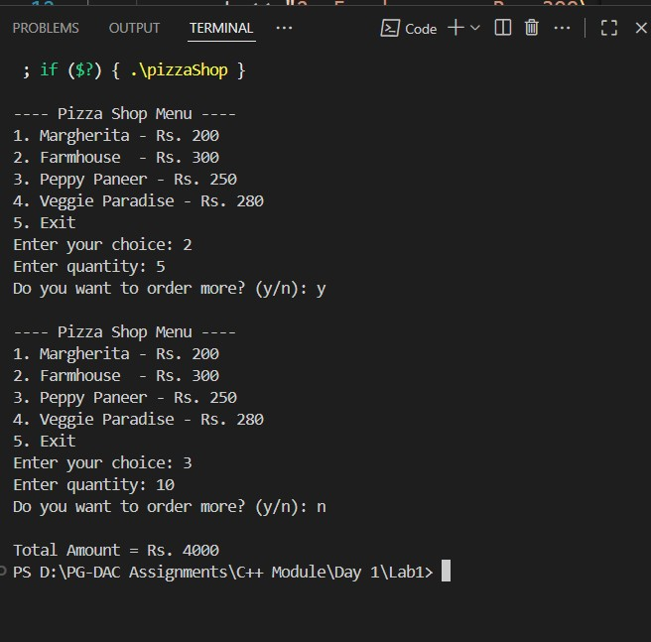
20:Accept a single digit from the user and display it in words. For example, if digit entered is 9, display Nine.
#include <bits/stdc++.h> using namespace std;

int main(int argc, char const *argv[])
{ int num; do
{
cout << "Enter the Numbers(0 to 9): " << endl; cin >> num;

switch (num)
{ case 0:
cout << "Zero" << endl; break;
case 1:
cout << "One" << endl; break;
case 2:
cout << "Two" << endl;
break;
case 3:
cout << "Three" << endl; break;
case 4:
cout << "Four" << endl; break; case 5: cout << "Five" << endl; break; case 6: cout << "Six" << endl; break; case 7:
cout << "Seven" << endl; break; case 8:
cout << "Eight" << endl; break; case 9:
cout << "Nine" << endl; break;
default:
cout << "Invalid Choice..!" << endl;
}

} while (num != 10); return 0;
}
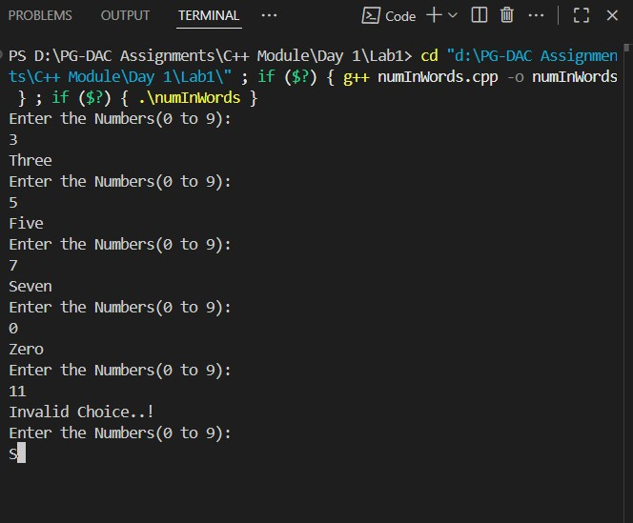
21. Write a program, which accepts two integers and an operator as a character (+ - * / ), performs the
corresponding operation and displays the result.
#include<bits/stdc++.h> using namespace std;

int main(int argc, char const *argv[])
{ char ch; long long num1,num2; do{

cout<<"Enter First Numbers: "<<endl; cin>>num1; cout<<"Enter the Second Number: "<<endl; cin>>num2; cout<<"---------Menu----------"<<endl; cout<<"Additon"<<endl; cout<<"Substraction"<<endl; cout<<"Multiplication"<<endl; cout<<"Division"<<endl; cout<<"Enter the Operation: "<<endl; cout<<" \n----------------------------------- \n"<<endl; cout<<"Enter the Operation: "<<endl; cin>>ch;
cout<<"\n"<<num1<<" "<<ch<<" "<<num2<<" \n"<<endl;
switch (ch)
{ case '+':
cout<<"sum is "<<num1+num2<<endl;
break;
case '-':
cout<<"Substraction is "<<abs(num1-num2)<<endl; break;
case '*':
cout<<"Multiplication is "<<num1*num2<<endl;
break;
case '/': if(num2<=0)
{ cout<<"Error......."<<endl;
}else{
cout<<"Division is "<<num1/num2<<endl;
} break;
default:
cout<<"Invalid Operation!"<<endl;
}

}while(ch != '\0'); return 0;
}
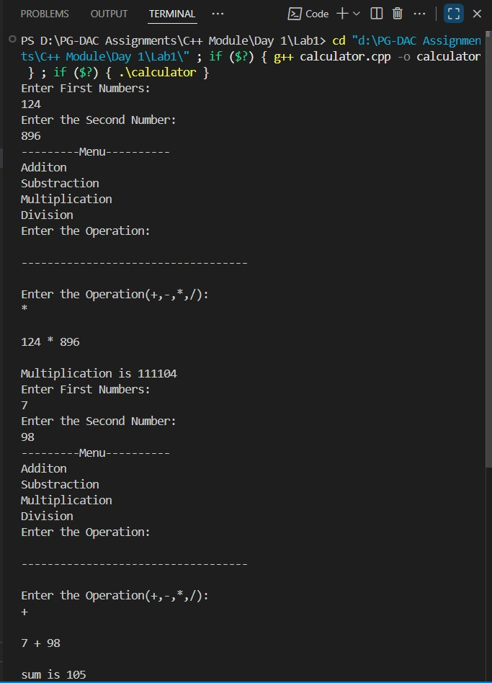

Lab 2

1:Write a program that accepts numbers continuously as long as the number is positive and prints the sum of the given numbers. #include<bits/stdc++.h> using namespace std;

int main(int argc, char const *argv[])
{ int num,sum = 0; cout<<"Enter the number: "<<endl;
do{ cin>>num; if(num%2 >=0) sum += num; }while(num != 0); cout<<"sum is "<<sum<<endl;
return 0;
}
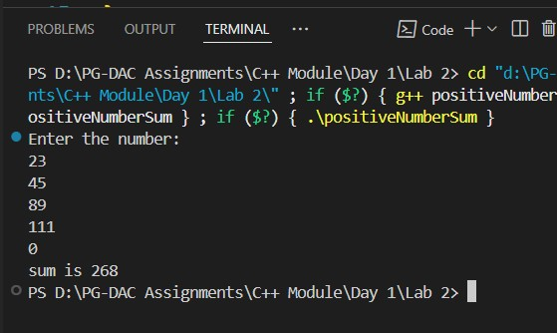
2. Write a program to accept two integers x and n and compute x raised to n. #include<bits/stdc++.h> using namespace std;

int main(int argc, char const *argv[])
{ int x,n,result = 1; cout<<"Enter the number(x): "<<endl; cin>>x; cout<<"Enter the power(n): "<<endl; cin>>n; if(n<0)
{
cout<<"Enter +ve integer only"<<endl;
return 0; } for(int i =0; i<n;i++)
{ result *=x;
}
cout<<x<<"^"<<n<<" is "<<result<<endl;
return 0;
}
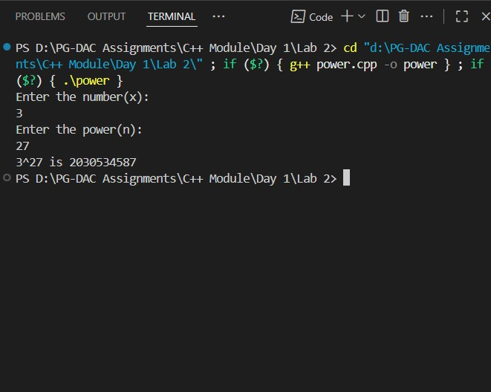
3. Write a program to accept a character, an integer n and display the next n characters. #include<bits/stdc++.h> using namespace std;

int main(int argc, char const *argv[])
{ char ch; int num; cout<<"Enter the (Lowercase) character: "<<endl; cin>>ch; cout<<"Enter the number: "<<endl; cin>>num; if(num<0)
{
cout<<"Enter only +ve integer."<<endl;
return 0;
} for(int i =1; i<= num;i++)
{
cout<<(char)(ch+i)<<" "<<endl;
} return 0;
}
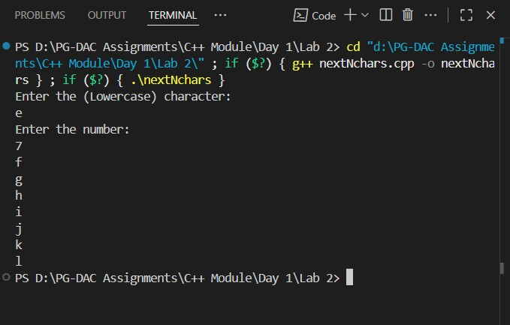
4. Write a program to calculate factorial of a number.
For e.g. factorial of 5 = 5! = 5 *4*3*2*1 = 120

#include<bits/stdc++.h> using namespace std;

int main(int argc, char const *argv[])
{ int num,fact = 1; cout<<"Enter the +ve Integer: "<<endl; cin>>num; if(num <= 0) return 1;
for(int i = 1; i<=num;i++) fact*=i; cout<<"The factorial of "<<num<<" is "<<fact<<endl;
return 0;
}


5. Write a program to calculate factors of a given number. #include<bits/stdc++.h> using namespace std;

int main(int argc, char const *argv[])
{ int num,flag; cout<<"Enter the number: "<<endl; cin>>num; if(num< 0)
{
cout<<"Enter only +ve integer only."<<endl; return 0;
} cout<<"Factors of "<<num<<" are: "<<endl; for(int i =1;i<=num;i++)
{ flag = 0; if(num%i == 0)
flag = 1; if(flag == 1)
{ cout<<i<” ”;
} } return 0;
}
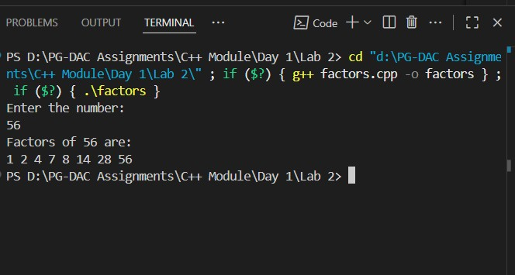
6. Accept two numbers and calculate GCD of them. #include <iostream> using namespace std;

int main() {
int a, b;
cout << "Enter two numbers: "; cin >> a >> b;

while (b != 0) { int temp = b; b = a % b; a = temp;
}

cout << "GCD = " << a << endl;
return 0;
}
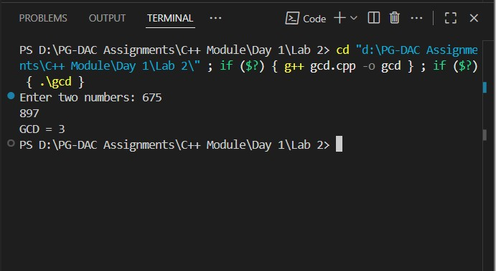
7. Write a menu driven program to do following operations :
- Compute area of circle
- Compute area of rectangle
- Compute area of triangle
- Exit
Display menu, ask choice to the user, depending on choice accept the parameters and perform the operation. Continue this process until user selects exit option.

#include <bits/stdc++.h> #define PI 3.14 using namespace std;

int main(int argc, char const *argv[])
{ int choice; float radius, length, breadth, base, height; cout << "---------Menu-----------" << endl; cout << "1) Area of Circle " << endl; cout << "2) Area of Rectangle " << endl; cout << "3) Area of Triangle " << endl; cout << "4) Exit " << endl; do
{
cout << "Enter the choice: " << endl; cin >> choice; switch (choice)
{ case 1:
cout << "Enter the radius of a circle: " << endl; cin >> radius; if (radius <= 0)
{
cout << "Enter valid Radius..!" << endl;
return 0;
} else
{
cout << "Area of the circle is " << PI * radius * radius << endl;
}
break;
case 2:
cout << "Enter the length and breadth of a rectangle: " << endl; cin >> length >> breadth; if (length <= 0 || breadth <= 0)
{
cout << "Enter Valid Length and Breadth" << endl;
} else
{
cout << "Area of a rectangle is " << length * breadth << endl;
} break;
case 3:
cout << "Enter the base and height of triangle: " << endl; cin >> height >> base; if (height <= 0 || base <= 0)
{
cout << "Enter the valid height and base." << endl;
return 0;
} else
{
cout << "Area of a Triangle is " << 0.5* base * height << endl;
} break; case 4:
cout << "Program Exited...!" << endl;
break;

default:
cout << "Invalid Choice " << endl;
}
} while (choice != 4);

return 0;
}
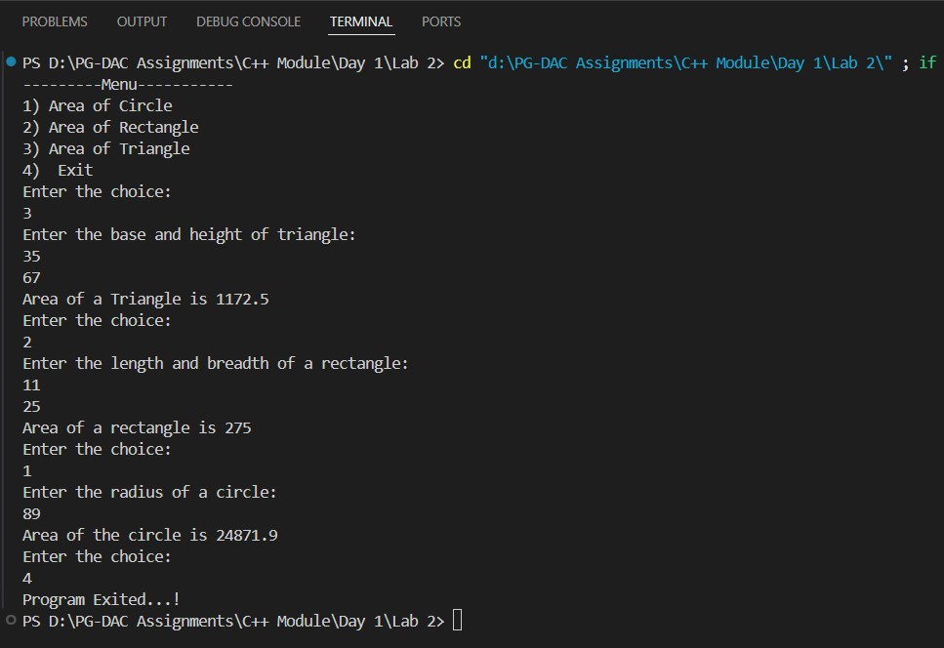
8. Write a program to print all prime numbers between 1 to n

#include<bits/stdc++.h> using namespace std;

int main(int argc, char const *argv[])
{ int num; cout<<"Enter the number: "<<endl; cin>>num;
if(num <= 1)
{
cout<<"Not a Prime Number!"<<endl;
return 0;
}

for(int i = 2;i<=num;i++)
{ int flag=0; for(int j = 2;j <=i/2;j++)
{ if(i%j==0){ flag=1; break; }
} if(flag==0)
{
cout<<i<<endl;
}
}

return 0; }


Lab 3

1:Write a program to create an array of integers and perform following operations on that array like
finding the sum, average, maximum and minimum number in that array. Accept the numbers of the array from user. #include <bits/stdc++.h> using namespace std; #define MAX 500
int main(int argc, char const *argv[])
{ int size, choice, index = 0, total, mini, maxi; int arr[MAX]; cout << "Enter the size of the array: " << endl; cin >> size; if (size <= 0)
{
cout << "Please Enter +ve size only..!" << endl; return 0;
}

cout << "--------------Menu------------" << endl; cout << "1) Input Array Elements " << endl; cout << "2) Display Array " << endl; cout << "3) Sum of Array Elements " << endl; cout << "4) Average of Array Elements " << endl; cout << "5) Maximum and Minimum element in array " << endl; cout << "6) Exit" << endl;
do { cout << "Enter the choice: " << endl; cin >> choice; switch (choice)
{ case 1: if (index < size)
{
cout << "Enter the Elements in array: " << endl; cin >> arr[index++];
} else
{
cout << "Sorry! Array is Full." << endl;
} break;
case 2: if (index <= 0)
{
cout << "Your array is Empty.Please Enter the Elements.\n"
<< endl;
} else
{
cout << "Your array is " << endl; for (int i = 0; i < index; i++)
{ cout << arr[i] << endl;
} } break; case 3:
total = 0; if (index <= 0)
{
cout << "Your array is Empty. So sum is zero"
<< endl;
} else { for (int i = 0; i < index; i++)
{ total += arr[i];
}
cout << "Total sum of the Array Elements is " << total << endl;
} break;
case 4:

if (index <= 0)
{
cout << "Your array is Empty. So Average sum of Array elements is zero" << endl;
} else
{
cout << "Total Average sum of the Array Elements is " << (float)total / index << endl;
} break;
case 5:
if (index <= 0)
{
cout << "Array is Empty..!" << endl;
} else
{ maxi = arr[0]; mini = arr[0]; for (int i = 1; i < index; i++)
{ if (arr[i] > maxi) maxi = arr[i]; if (arr[i] < mini) mini = arr[i];
}
cout << "The Largest Element in array is " << maxi
<< " and Smallest Element in array is " << mini << endl;
} break;
case 6:
cout << "Program Exited..!" << endl;
break;
default:
cout << "Invalid Choice..!\n please Enter the Valid Choice..." << endl;
}
} while (choice < 6); return 0;
}
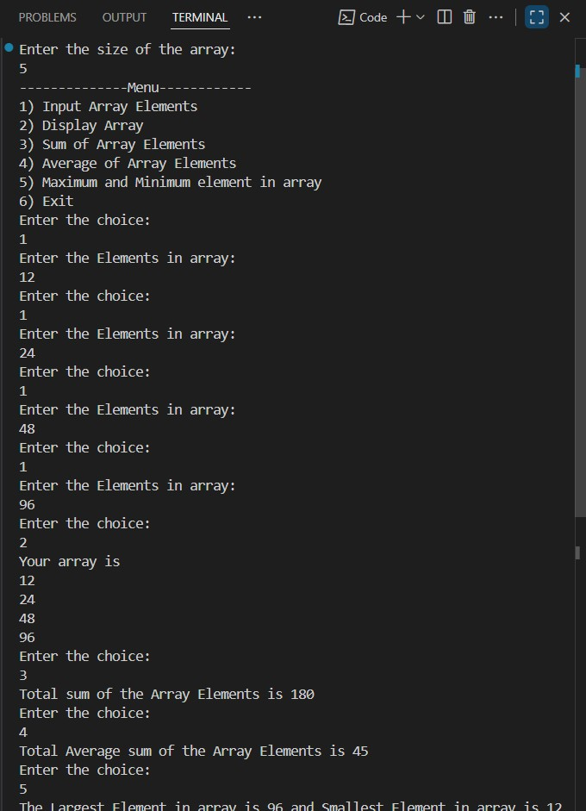
2: Write a program to Accept a number and display its sum of digits.:ex 568 5+6+8
#include<bits/stdc++.h> using namespace std;

int main(int argc, char const *argv[])
{ int num,org, temp = 0; cout<<"Enter the number: "<<endl; cin>>num; org = num; while(num != 0)
{
temp += num%10; num = num/10;
}
cout<<"sum of digits of "<<org<<" is "<<temp<<endl;
return 0;
}
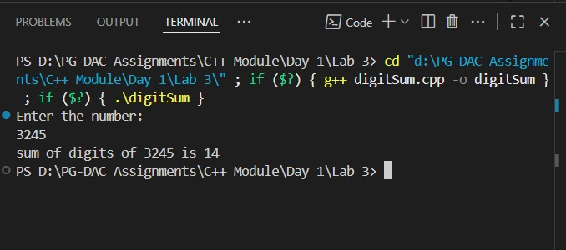
6:Write a program to print following pattern.
*
- *
- * *
- * * *
- * * * *

#include<bits/stdc++.h>
using namespace std;

int main(int argc, char const *argv[])
{ int num; cout<<"Enter the number: "<<endl; cin>>num; if(num<=0)
{
cout<<"Enter the valid number..!"<<endl;
return 0;
} for(int i = 0; i< num;i++)
{ for(int j =0;j<=i;j++)
{ cout<<" * ";
}
cout<<endl;
} return 0;
}
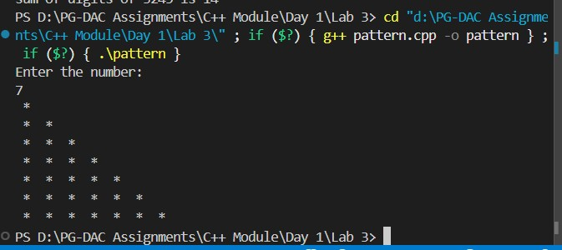

7:Write a program to create student class with data members rollno, marks1,mark2,mark3.
Accept data (acceptInfo()) and display using display member function.
Also display total,percentage and grade.
#include <iostream> using namespace std;

class Student { private:
int rollno; float marks1, marks2, marks3;

public:
void setRollNo(int r) { rollno = r; } void setMarks1(float m) { marks1 = m; } void setMarks2(float m) { marks2 = m; } void setMarks3(float m) { marks3 = m; }

int getRollNo() { return rollno; } float getMarks1() { return marks1; } float getMarks2() { return marks2; } float getMarks3() { return marks3; }

void acceptInfo() {
int r;
float m1, m2, m3; cout << "Enter Roll No: "; cin >> r; setRollNo(r); cout << "Enter marks of 3 subjects: "; cin >> m1 >> m2 >> m3; setMarks1(m1);
setMarks2(m2); setMarks3(m3);
}

void display() { float total = marks1 + marks2 + marks3; float percentage = total / 3; char grade;

if (percentage >= 75) grade = 'A'; else if (percentage >= 60) grade = 'B'; else if (percentage >= 50) grade = 'C'; else if (percentage >= 35) grade = 'D'; else grade = 'F';

cout << "\nRoll No: " << getRollNo() << endl; cout << "Marks: " << getMarks1() << ", " << getMarks2() << ", " << getMarks3() << endl; cout << "Total: " << total << endl; cout << "Percentage: " << percentage << "%" << endl; cout << "Grade: " << grade << endl;
}
};

int main() { Student s;
s.acceptInfo();
s.display();
return 0;
}
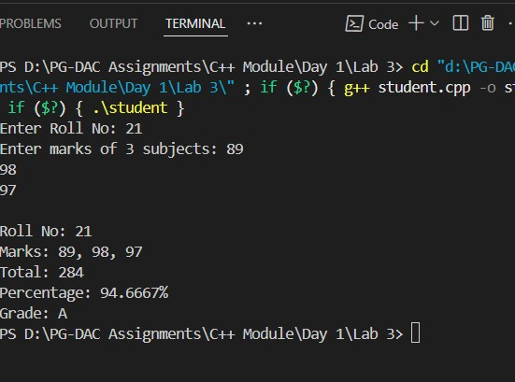

Day 2 Lab

Assignment: Inline Functions in C++

Task

Write a program using inline functions to calculate:

Area of a square (side × side) #include<bits/stdc++.h> using namespace std; inline int area(int &side)
{ return side*side;
} int main(int argc, char const *argv[])
{ int side; cout<<"Enter the length of side of square: "<<endl; cin>>side; cout<<"Area of the square is "<<area(side)<<endl;
return 0;
}
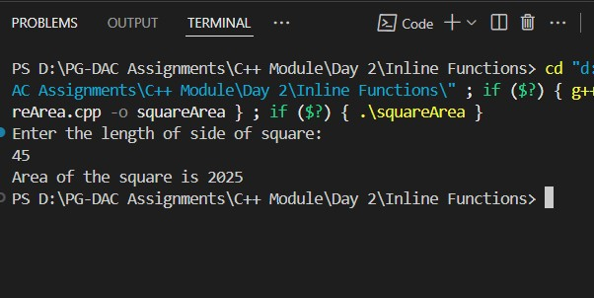

Area of a rectangle (length × breadth)
#include<bits/stdc++.h> using namespace std;

inline int area(int length,int breadth)
{ return length*breadth;
} int main(int argc, char const *argv[])
{ int length,breadth; cout<<"Enter the length and breadth of rectangle: "<<endl; cin>>length>>breadth; cout<<"Area of the rectangle "<<area(length,breadth)<<endl;
return 0;
}

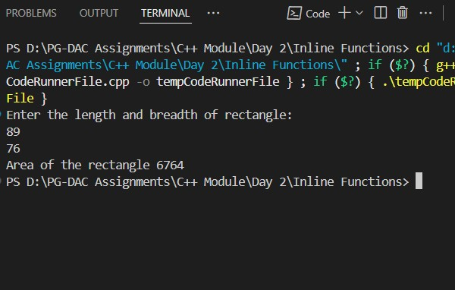

Area of a circle (π × r × r, use π = 3.14159)

#include <bits/stdc++.h> using namespace std;
#define PI 3.14159

inline float area(float radius)
{ return PI* radius * radius;
}

int main(int argc, char const *argv[])
{ float radius; cout << "Enter the radius of circle: " << endl; cin >> radius; cout << "Area of the circle is " << area(radius) << endl; return 0;
}
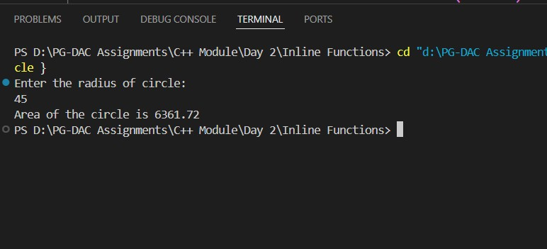

Array_Lab

Basic Array Lab Assignments

1. Array Input & Output**

* Take `n` elements from the user and display them.
#include<bits/stdc++.h> using namespace std; #define MAX 500
int main(int argc, char const *argv[])
{ int size,choice,index = 0; int arr[MAX]; cout<<"Enter the size of the array: "<<endl; cin>>size; if(size <= 0)
{
cout<<"Please Enter +ve size only..!"<<endl;
return 0;
}

do
{

cout<<"--------------------Menu-----------------"<<endl; cout<<"1)Enter Elements in Array "<<endl; cout<<"2) Display "<<endl; cout<<endl; cout<<"Enter the choice: "<<endl;
cin>>choice; switch(choice)
{ case 1:
if(index< size){ cout<<"Enter the Elements in array: "<<endl; cin>>arr[index++];
}else
{
cout<<"Sorry! Array is Full."<<endl;
} break;
case 2: if(index <= 0)
{
cout<<"Your array is Empty.Please Enter the Elements.\n"<<endl;
} else
{
cout<<"Your array is "<<endl; for(int i = 0; i< index;i++)
{ cout<<arr[i]<<endl;
} } break; default:
cout<<"Invalid Choice..!\n please Enter the Valid Choice..."<<endl;
}
} while(choice <3); return 0;
}
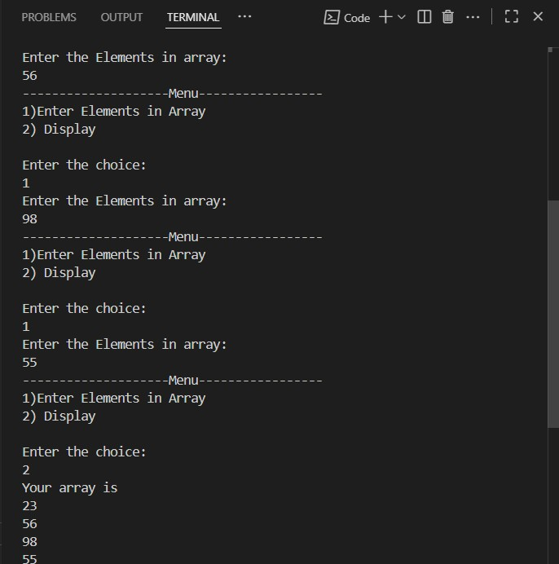

2. Sum & Average of Array**
* Input marks of `n` students, find total & average.

3. Find Maximum and Minimum**
* Input array and print the largest & smallest element.
#include <bits/stdc++.h> using namespace std; #define MAX 500

int main() { int size, choice, index = 0; int arr[MAX];

cout << "Enter the size of the array: "; cin >> size;

if (size <= 0) { cout << "Please enter a positive size only!" << endl; return 0;
}

do { cout << "\n---- Menu ----\n"; cout << "1. Insert Element\n"; cout << "2. Display Array\n"; cout << "3. Sum of Elements\n"; cout << "4. Average of Elements\n"; cout << "5. Minimum and Maximum Elements\n";
cout << "6. Exit\n"; cout << "Enter your choice: "; cin >> choice;

switch (choice) { case 1:
if (index < size) { cout << "Enter element: "; cin >> arr[index++];
} else { cout << "Array is full!" << endl;
} break;
case 2:
if (index <= 0) { cout << "Array is empty. Please insert elements first." << endl;
} else { cout << "Array elements: "; for (int i = 0; i < index; i++) cout << arr[i] << " "; cout << endl;
} break;
case 3:
if (index <= 0) { cout << "Array is empty. Sum is 0." << endl;
} else { int total = 0; for (int i = 0; i < index; i++) total += arr[i]; cout << "Sum of elements: " << total << endl;
} break;
case 4:
if (index <= 0) { cout << "Array is empty. Average is 0." << endl; } else { int total = 0; for (int i = 0; i < index; i++) total += arr[i]; cout << "Average of elements: " << (float)total / index << endl;
} break;
case 5:
if (index <= 0) { cout << "Array is empty." << endl;
} else { int mini = arr[0], maxi = arr[0]; for (int i = 1; i < index; i++) { if (arr[i] < mini) mini = arr[i]; if (arr[i] > maxi) maxi = arr[i];
}
cout << "Minimum element: " << mini << endl; cout << "Maximum element: " << maxi << endl;
} break;
case 6:
cout << "Exiting program..." << endl;
break;
default:
cout << "Invalid choice! Please enter a valid choice." << endl;
}

} while (choice != 6);

return 0;
}

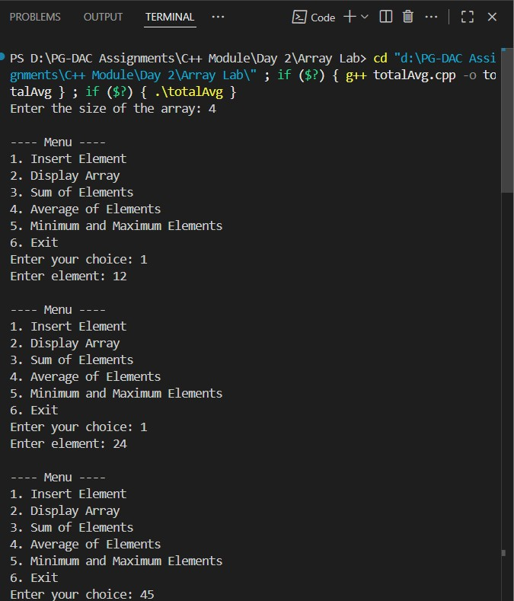
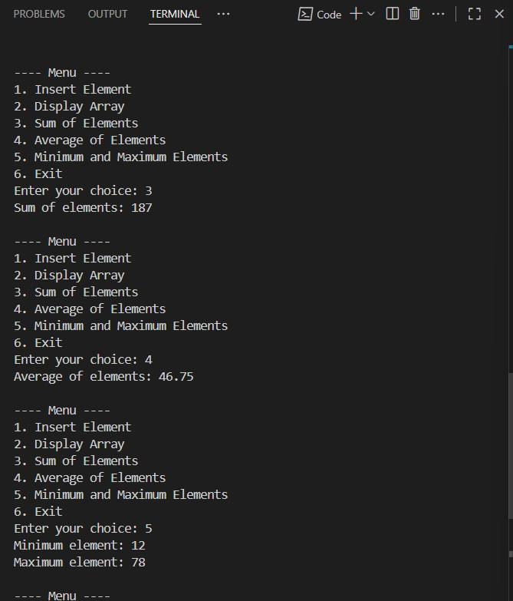

4. Search an Element (Linear Search)**

* Input an array and search if a number exists.
#include<bits/stdc++.h> #define MAX 500 using namespace std;

int main(int argc, char const *argv[])
{ int size,element,arr[MAX],flag; cout<<"Enter the size of the array: "<<endl; cin>>size; if(size <= 0)
{
cout<<"Ente the +ve size only."<<endl; return 0;
}
cout<<"Enter the Elements in array: "<<endl; for(int i =0;i<size;i++)
{ cin>>arr[i];
}
cout<<"Enter the element that you want to search: "<<endl; cin>>element; for(int i =0;i<size;i++)
{ flag = 0; if(arr[i]==element)
{ flag = 1; break;
}
}

if(flag == 1) cout<<element<<" is present in array."<<endl;
else
cout<<element<<" is not present in array"<<endl;
return 0;
}
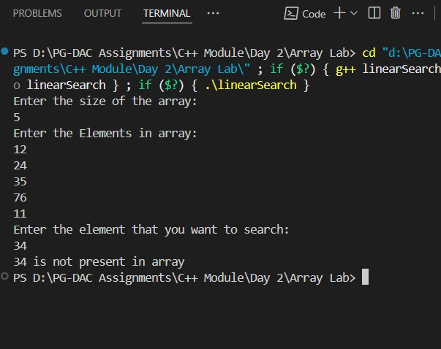

5. Reverse Array**

* Reverse an array and display the result.

#include<bits/stdc++.h> #define MAX 500 using namespace std;

int main(int argc, char const *argv[])
{ int size,element,arr[MAX],flag; cout<<"Enter the size of the array: "<<endl; cin>>size; if(size <= 0)
{ cout<<"Ente the +ve size only."<<endl; return 0;
}
cout<<"Enter the Elements in array: "<<endl; for(int i =0;i<size;i++)
{ cin>>arr[i];
}
cout<<"Your original array "<<endl; for(int i =0;i<size;i++)
{
cout<<arr[i]<<endl;
}
cout<<"Reversed Array: "<<endl; for(int i = size-1;i>=0;i--)
{
cout<<arr[i]<<endl;
} return 0;
}
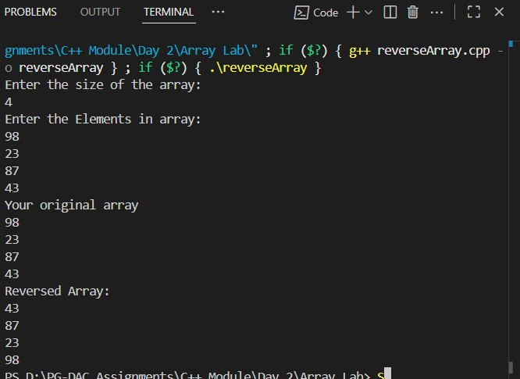
## Intermediate Array Lab Assignments

6. Count Even and Odd Numbers**

* Count how many even and odd numbers are in the array.
#include<bits/stdc++.h> #define MAX 500 using namespace std;

int main(int argc, char const *argv[])
{ int size,element,arr[MAX],even = 0,odd= 0; cout<<"Enter the size of the array: "<<endl; cin>>size; if(size <= 0)
{
cout<<"Ente the +ve size only."<<endl; return 0; } cout<<"Enter the Elements in array: "<<endl; for(int i =0;i<size;i++)
{ cin>>arr[i];
}
cout<<"Your array is "<<endl; for(int i =0 ;i < size;i++)
{
cout<<arr[i]<<endl; if(arr[i]%2==0)
{ even++;
} else{ odd++;
}
}

cout<<"No. of even numbers in array are "<<even<<" and No. of odd numbers in array are "<<odd<<endl;

return 0;
}
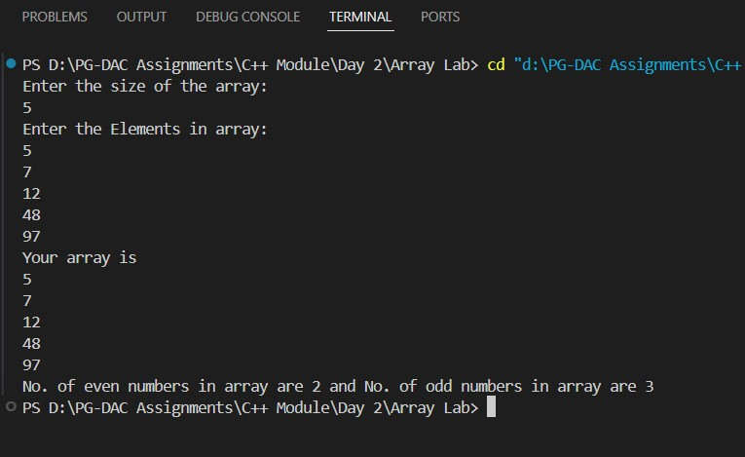

7. Sort Array (Ascending & Descending)**

* Implement a simple bubble sort.
#include<bits/stdc++.h> #define MAX 500 using namespace std;

int main(int argc, char const *argv[])
{ int size,element,arr[MAX],temp; cout<<"Enter the size of the array: "<<endl; cin>>size; if(size <= 0)
{
cout<<"Ente the +ve size only."<<endl; return 0;
}
cout<<"Enter the Elements in array: "<<endl;
for(int i =0;i<size;i++)
{ cin>>arr[i];
} cout<<"Your original array "<<endl; for(int i =0;i<size;i++)
{
cout<<arr[i]<<endl;
}

for(int j = 0; j<size;j++)
{ for(int i =0 ; i< size-1; i++){ if(arr[i]>arr[i+1])
{ temp = arr[i]; arr[i] =arr[i+1]; arr[i+1] = temp;
}
}
}
cout<<"Your sorted array(in ascending order): "<<endl; for(int i =0;i<size;i++)
{
cout<<arr[i]<<endl;
}

for(int j = 0; j<size;j++)
{ for(int i =0 ; i< size-1; i++){ if(arr[i]<arr[i+1])
{ temp = arr[i]; arr[i] =arr[i+1]; arr[i+1] = temp;
}
}
}

cout<<"Your sorted arrayl(in decending order): "<<endl; for(int i =0;i<size;i++)
{
cout<<arr[i]<<endl;
}
}

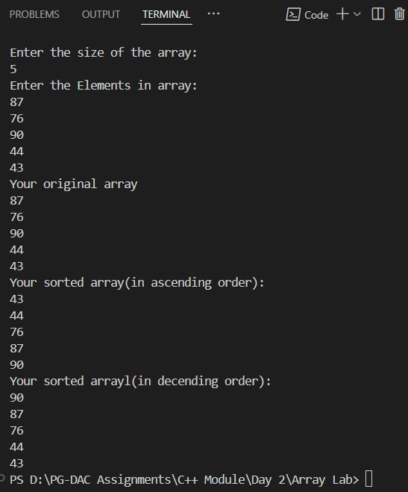

8.Second Largest Element**

* Find the second largest number without sorting.
#include <bits/stdc++.h> #define MAX 500 using namespace std;

int main() {
int size; int arr[MAX];

cout << "Enter the size of the array: " << endl; cin >> size;

if (size <= 1) { cout << "Need at least 2 elements to find second largest." << endl; return 0;
}

cout << "Enter the elements in array: " << endl; for (int i = 0; i < size; i++) { cin >> arr[i];
}

cout << "Your array: " << endl; for (int i = 0; i < size; i++) { cout << arr[i] << " ";
}
cout << endl;

// Find largest and second largest int largest = INT_MIN, secondLargest = INT_MIN;

for (int i = 0; i < size; i++) { if (arr[i] > largest) { secondLargest = largest; // update second largest largest = arr[i]; // update largest
}
else if (arr[i] > secondLargest && arr[i] != largest) { secondLargest = arr[i];
}
}

if (secondLargest == INT_MIN) { cout << "No second largest element found (all elements are equal)." << endl;
} else { cout << secondLargest << " is the Second Largest Element in array." << endl;
}

return 0;
}

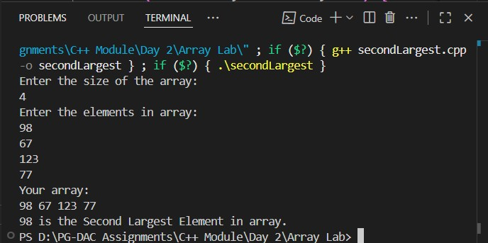

9. Frequency of Each Element**

* Count how many times each element occurs.
// Frequency of Each Element**

// * Count how many times each element occurs.
#include <bits/stdc++.h> #define MAX 500 using namespace std;

int main() { int size, arr[MAX]; cout << "Enter the size of the array: " << endl; cin >> size;

if (size <= 0) { cout << "Enter +ve size only" << endl; return 0;
}

cout << "Enter the Elements in array: " << endl; for (int i = 0; i < size; i++) { cin >> arr[i];
}

cout << "Given array: "; for (int i = 0; i < size; i++) cout << arr[i] << " "; cout << endl;

cout << "\nFrequency of elements:\n"; bool visited[MAX] = {false};
for (int i = 0; i < size; i++) { if (visited[i]) continue;
int cnt = 1; for (int j = i + 1; j < size; j++) { if (arr[i] == arr[j]) { cnt++; visited[j] = true;
}
}
cout << arr[i] << " occurs " << cnt << " times\n";
}

return 0;
}

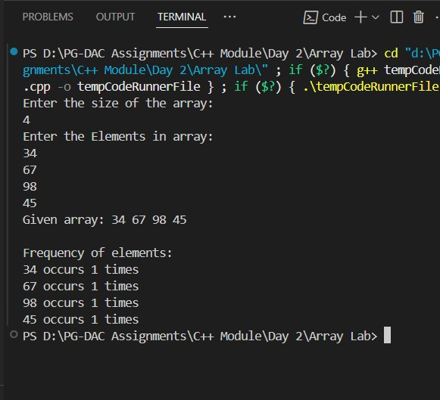

10. Merge Two Arrays**

* Take two arrays and merge them into a third array.
#include<bits/stdc++.h> #define MAX 500 using namespace std;

int main(int argc, char const *argv[])
{ int size1, size2; int arr1[MAX],arr2[MAX];
// first array cout<<"Enter the size of the first array: "<<endl; cin>> size1; if(size1 <= 0)
{
cout<<"Enter +ve size only"<<endl;
return 0;
}
cout<<"Enter the Elements in first array: "<<endl; for(int i = 0; i< size1; i++)
{ cin>>arr1[i];
}

cout<<"Your first array: "<<endl; for(int i = 0; i< size1; i++)
{ cout<<arr1[i]<<endl;
}

// second array cout<<"Enter the size of the second array: "<<endl; cin>> size2; if(size2 <= 0)
{
cout<<"Enter +ve size only"<<endl;
return 0;
}
cout<<"Enter the Elements in second array: "<<endl; for(int i = 0; i< size2; i++)
{ cin>>arr2[i];
}

cout<<"Your second array: "<<endl; for(int i = 0; i< size2; i++)
{
cout<<arr2[i]<<endl;
}

int size3 = size1+ size2, arr3[size3];
// while(arr1[size1-1] != 0 )
// {
// int temp = size1-1;
// arr3[i++] = arr1[temp--];
// }

// while(arr2[size2-1] != 0 )
// {
// int temp = size2-1;
// arr3[size1++] = arr2[temp--];
// }
// cout<<"Merged Final array: "<<endl;
// for(int i = 0; i< size1+size2; i++)
// {
// cout<<arr3[i]<<endl;
// }

for(int i = 0; i<size1;i++)
{ arr3[i] =arr1[i]; } for(int i = 0; i < size2; i++)
{ arr3[size1+i] = arr2[i];
}

cout<<"Merged Final array: "<<endl; for(int i = 0; i< size3; i++)
{
cout<<arr3[i]<<endl;
} return 0; }
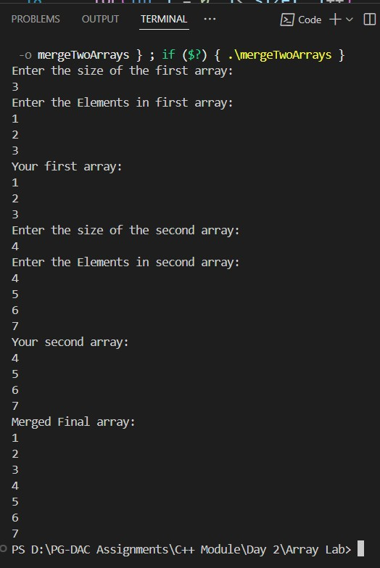

Day 3

1:Write a program to create student class with data members rollno, marks1,mark2,mark3.
Accept data (acceptInfo()) and display using display member function.
Also display total,percentage and grade.
#include <bits/stdc++.h> using namespace std;

class Student { private:
int rollno; int mark1; int mark2; int mark3;

public:
int total; double percentage; char grade;

void acceptInfo() { cout << "Enter Roll No: "; cin >> rollno;

cout << "Enter marks of first subject: "; cin >> mark1;

cout << "Enter marks of second subject: "; cin >> mark2;

cout << "Enter marks of third subject: "; cin >> mark3;

total = mark1 + mark2 + mark3; percentage = (double)total / 3.0; // correct calculation
}

void Display() { cout << "\n------------------Student Details:------------------------------"<< endl; cout << "Roll No: " << rollno << endl; cout << "Marks: " << mark1 << ", " << mark2 << ", " << mark3 << endl; cout << "Total Marks: " << total << endl; cout << "Percentage: " << percentage << "%" << endl;

// Assign grade based on percentage if (percentage >= 91 && percentage <= 100) { cout << "Grade: A+" << endl; } else if (percentage >= 81) { cout << "Grade: A" << endl; } else if (percentage >= 71) { cout << "Grade: B" << endl; } else if (percentage >= 61) { cout << "Grade: C" << endl; } else if (percentage >= 51) { cout << "Grade: D" << endl; } else if (percentage >= 41) { cout << "Grade: E" << endl;
} else { cout << "Grade: F (Fail)" << endl;
}
}
};

int main() { Student s;
s.acceptInfo(); // take input from user
s.Display(); // display info return 0;
}

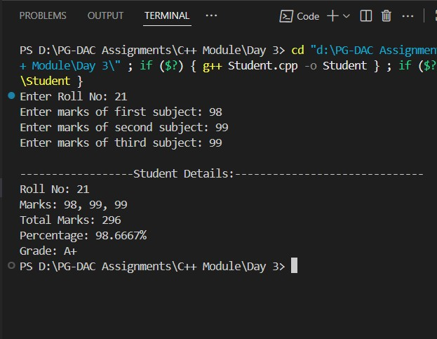
1. Create a class Person with data members as name, age, city. Write getters and setters for all the data
members. Also add the display function. Create Default and Parameterized constructors. Create the object of this class in main method and invoke all the methods in that class. #include<bits/stdc++.h> using namespace std;

class Person
{
// Data Members or Properties private:
string name; int age; string city;

//Methods or Behaviour public:
// Default Constructor
Person()
{
cout<<"------------Default Constructor Called----------------------------------"<<endl; name = "Vishwajit"; age = 23; city = "Pune";
}

//Parameterized Constructor
Person(string name,int age, string city)
{
cout<<"---------------------------Parameterized Constructor Called------------------------
--------"<<endl; this->name = name; this->age = age; this->city = city;
}
//setters void setName()
{
cout<<"Enter your name: "<<endl; cin>>name;
}

void setCityName()
{
cout<<"Enter the city Name: "<<endl; cin>>city;
}

void setAge()
{
cout<<"Enter your Age: "<<endl; cin>>age;

}
// Getters string getName()
{ return name;
}

int getAge()
{ return age;
}
string getCity()
{ return city;
}

//Display Function void Display()
{
cout<<"--------------------------Details of the Person-------------------------------
"<<endl; cout<<"Name of the Person: "<<name<<endl; cout<<"Your age is "<<age<<endl; cout<<"your city is "<<city<<endl;
}
};

int main(int argc, char const *argv[])
{
Person p1;
//Default Constructor call
// p1.Display();

//Parameterized constructor call Person p2("Sumant",22,"Mumbai"); p2.Display();

Person p3;
//call using setters p3.setName(); p3.setAge(); p3.setCityName();
//getName p3.getName(); p3.getAge(); p3.getCity();

p1.Display(); return 0;
}
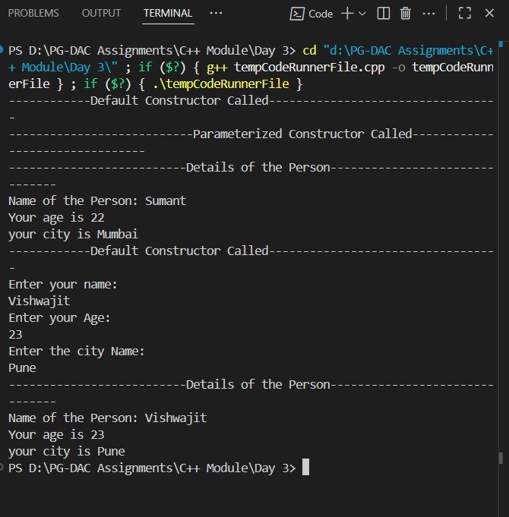

2. Create a class Date with data members as dd, mm, yy. Write getters and setters for all the data members. Also add the display function. Create Default and Parameterized constructors. Create the object of this class in main method and invoke all the methods in that class.
#include<bits/stdc++.h> using namespace std;

class Date
{
// Data Members or Properties private:
int dd; int mm; int yy; public:
// Default Constructor
Date()
{
cout<<"--------------------Default Constructor Called-------------------------"<<endl; dd = 26; mm = 8; yy = 2025;
}

//Parameterized Constructors
Date(int dd, int mm, int yy)
{
cout<<"--------------Parameterized Constructor Called------------------------"<<endl; this->dd = dd; this->mm = mm;
this->yy = yy;
}
//setters void setDay()
{
cout<<"Enter the day: "<<endl; cin>>dd;
}

void setMonth()
{
cout<<"Enter the Month: "<<endl; cin>>mm;
}

void setYear()
{
cout<<"Enter the Year: "<<endl; cin>>yy;
}

//Getters

int getDay()
{ return dd;
}

int getMonth()
{ return mm;
}

int getYear()
{ return yy;
}

//Display Function void Display()
{
cout<<"Date you Entered is: "<<endl; cout<<dd<<"/"<<mm<<"/"<<yy<<endl;
}

// ~Date() {}
}; int main(int argc, char const *argv[])
{
Date d1;
//Display Function called with default constructor d1.Display();

//Setters cout<<"----------------Setters--------------------------------"<<endl; Date d2; d2.setDay(); d2.setMonth();
d2.setYear();
//Getters cout<<"------------------------------------Getters----------------------------"<<endl; cout<<"Day "<<d2.getDay()<<endl; cout<<"Month: "<<d2.getMonth()<<endl; cout<<"Year: "<<d2.getYear()<<endl;

//Display Function d2.Display();

//Parameterized Constructor Date d3(7,11,2002); d3.Display();

return 0;
}
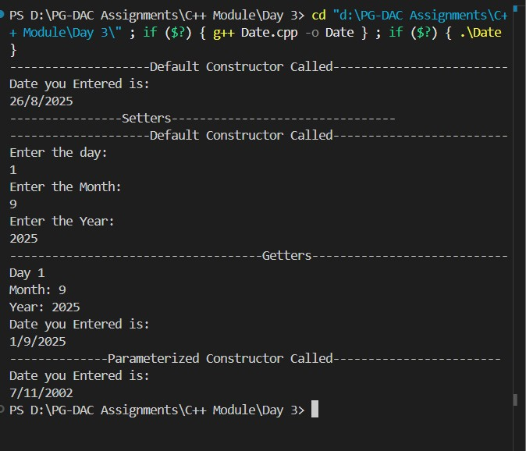
3. Create a class Book with data members as bname,id,author,price. Write getters and setters for all the
data members. Also add the display function. Create Default and Parameterized constructors. Create the object of this class in main method and invoke all the methods in that class.
#include<bits/stdc++.h> using namespace std;

class Book
{
//Data Members or Properties private:
string bookName; string author;
int bookId; double price; public:
//Default Constructor
Book()
{
cout<<"------------------Default Constructor Called--------------"<<endl; bookName = "Autobiography of Yogi"; author = "Paramhansa Yoganand"; bookId= 1927; price = 220;
}
//Parameterized Constructor
Book(string bookName,string author,int bookId,double price)
{
cout<<"------------------Parameterized Constructor Called-------------"<<endl; this->bookName = bookName; this->author = author; this->bookId = bookId; this->price = price;
}

//Setters
void setBookName()
{
cout<<"Enter the Book Name: "<<endl; getline(cin,bookName);
}

void setAuthor()
{ cout<<"Enter the name of author: "<<endl; getline(cin,author);
}

void setBookId()
{
cout<<"Enter the book Id"<<endl; cin>>bookId;
}

void setPrice()
{
cout<<"Enter the Price of the Book:"<<endl; cin>>price;
}

//Getters string getBookName()
{
return bookName;
}

string getAuthor()
{ return author;
}

int getBookId()
{
return bookId;
}

double getPrice()
{ return price;
}

//Display Function void display()
{
cout<<"-------------------------------Book Details------------------------------"<<endl; cout<<"Name of the Book: "<<bookName<<endl; cout<<"Author of the Book: "<<author<<endl; cout<<"Book Id: "<<bookId<<endl; cout<<"Price of the Book: "<<price<<endl;
}

}; int main(int argc, char const *argv[])
{
Book b1; b1.display();

//Direct Value set using parameterized constructor
Book b2("Billaniare's Mindset","Vishwajit Nikam",2002,750); b2.display();

//Value set using setters cout<<"----------------Using Setters---------------"<<endl; Book b3; b3.setBookName();
b3.setAuthor(); b3.setBookId(); b3.setPrice();

//Getters cout<<"-------------------Display Using Getters---------------------"<<endl; cout<<"Book Name: "<<b3.getBookName()<<endl; cout<<"Author of The Book"<<b3.getAuthor()<<endl; cout<<"Book Id: "<<b3.getBookId()<<endl; cout<<"Book Price: "<<b3.getPrice()<<endl;

return 0;
}
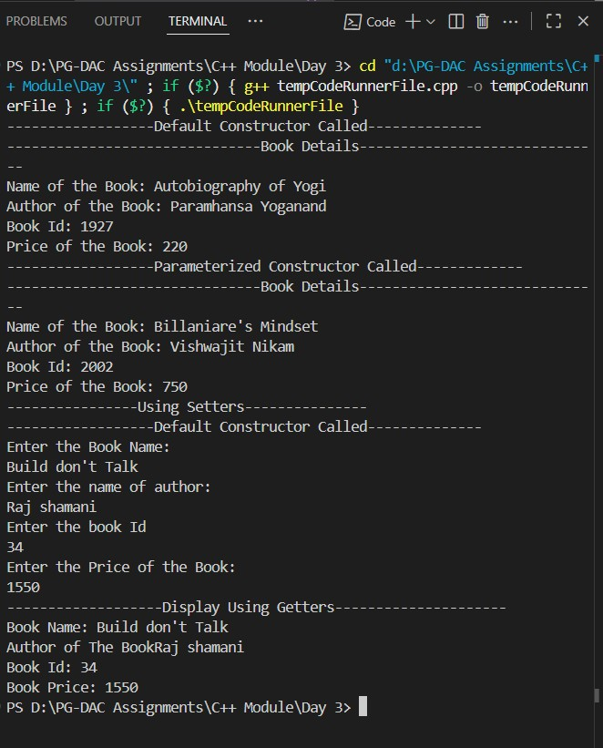
4. Create a class Point with data members as x,y. Create Default and Parameterized constructors. Write
getters and setters for all the data members. Also add the display function. Create the object of this class in main method and invoke all the methods in that class.
#include<bits/stdc++.h> using namespace std;

class Point { private:
int x; int y;

public:
//Default Constructor
Point()
{
cout<<"--------Default Constructor Called--------"<<endl; x = 100; y = 100;
}

//Parameterized Constructor
Point(int x, int y)
{
cout<<"------------Parameterized Constructor Called----------"<<endl; this->x=x; this->y=y;
}

//setters void setPointX()
{
cout<<"Enter the value for Point X: "<<endl;
cin>>x;
}

void setPointY()
{
cout<<"Enter the Value for Point Y: "<<endl; cin>>y;
}

//Getters int getPointX()
{ return x;
}

int getPointY()
{ return y;
}

//Display Function void Display()
{
cout<<"Value of X: "<<x<<endl; cout<<"Value of y: "<<y<<endl;
} }; int main(int argc, char const *argv[])
{
Point p1;
p1.Display();
Point p2(45,45); p2.Display();

cout<<"------------Value Set Using Setters------------"<<endl; Point p3; p3.setPointX(); p3.setPointY();

cout<<"-----------Getters---------------"<<endl; cout<<"Value for Point X: "<<p3.getPointX()<<endl; cout<<"Value for Point Y: "<<p3.getPointY()<<endl;

return 0;
}
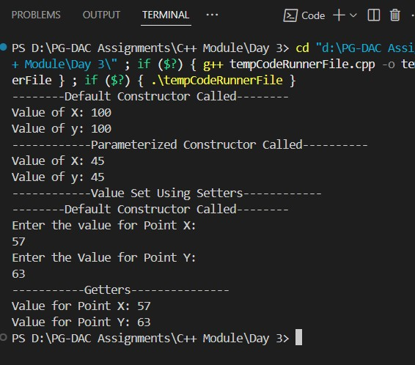

5. Create a class ComplexNumber with data members real, imaginary. Create Default and Parameterized constructors. Write getters and setters for all the data members. Also add the display function. Create the object of this class in main method and invoke all the methods in that class. #include<bits/stdc++.h> using namespace std;

class complexNumber
{
//Data Members or Properties private:
int real; int img; public:
//Default Constructor
complexNumber()
{
cout<<"-------------------------Default Constructor Called-----------------"<<endl; real = 23; img = 77;
}

//Parameterized Constructor complexNumber(int real,int img)
{
cout<<"---------------------Parameterized Constructor Called-----------------------
"<<endl;
this->real = real; this->img = img;
}

//Setters void setRealPart()
{
cout<<"Enter the Real Number Part: "<<endl; cin>>real;
}

void setImgPart()
{
cout<<"Enter Imginary Number Part: "<<endl; cin>>img;
}

//Getters int getRealPart() { return real;
}
int getImgPart()
{ return img;
}

//Display Function

void displayComplexNumber()
{ if(img>0)
{
cout<<"Your Complex Number is: "<<real<<"+"<<img<<"i"<<endl;
} else
{
cout<<real<<"-"<<img<<"i"<<endl;
}
}

}; int main(int argc, char const *argv[])
{ complexNumber c1; c1.displayComplexNumber(); complexNumber c2(11,-19); c2.displayComplexNumber();
complexNumber c3;
c3.setRealPart(); c3.setImgPart();

cout<<"Real Part: "<<c3.getRealPart()<<endl; cout<<"Imaginary Part: "<<c3.getImgPart()<<endl; c3.displayComplexNumber();
return 0;
}
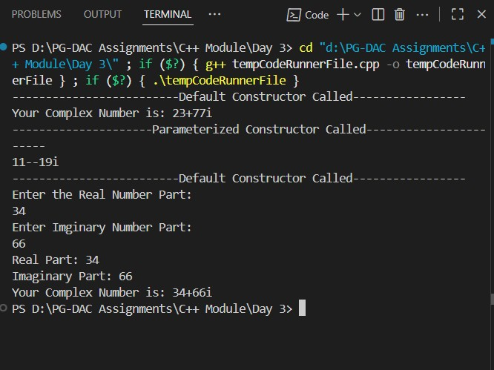

Day 4
Lab 5

1:Create Date class with members day,month ,year.
Write no argument and parameterised constructor .Create two object s and initialize them using no argument and parameterised constructor respectively.Print date using display function.
#include<bits/stdc++.h> using namespace std;

class Date
{
//Data Members or Properties private:
int day; int month; int year;

//Methods or Behaviour public:
//Default Constructor
Date()
{
cout<<"-----Default Constructor-------------"<<endl;
day = 26; month = 8; year = 2025;
}

//Parameterized Constructor
Date(int day,int month,int year)
{
cout<<"------------Parameterized Constructor---------------"<<endl; this->day =day; this->month = month;
this->year = year;
}

//Setters void setDay()
{
cout<<"Enter the day: "<<endl;
cin>>day; if(day<=0 || day > 31) cout<<"Enter Valid Day"<<endl;
}

void setMonth()
{
cout<<"Enter the Month: "<<endl; cin>>month; if(month<1 || month > 12) cout<<"Enter Valid Month"<<endl;
}

void setYear()
{
cout<<"Enter the Year: "<<endl;
cin>>year; if(year <= 00 and year > 2026)
{
cout<<"Enter the Valid Year..."<<endl;
}
}

//Getters int getDay()
{
return day;
}

int getMonth()
{
return month;
}

int getYear()
{
return year;
}

void displayDate()
{
if(month == 2 && day > 28 && year%4 != 0)
{
cout<<"Invalid Date...."<<endl;
}
else if(month == 2 && day > 29 && year%4 == 0)
{
cout<<"InValid Date...!"<<endl;
}
else if ((month == 1 || month == 3 || month == 5 || month == 7 || month == 8 ||
month == 10 || month == 12) && day<=31)
{
cout<<"Yor Date is "<<day<<"/"<<month<<"/"<<year<<endl;
}
else if((month == 4 || month == 6 || month == 9 || month == 11) && (day<=30))
{
cout<<"Yor Date is "<<day<<"/"<<month<<"/"<<year<<endl;
}

}

};
int main(int argc, char const *argv[])
{

// Default Constructors Date d1; d1.displayDate();

//Parameterized Constructors Date d2(29,2,2015); d2.displayDate();

// Setters
Date d3;
d3.setDay(); d3.setMonth(); d3.setYear();
// Getters cout<<"Date: "<<d3.getDay()<<"/"<<d3.getMonth()<<"/"<<d3.getYear()<<endl;

return 0;
}
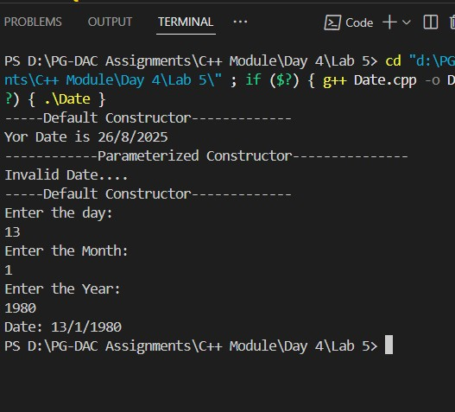
2:Create Employee class with members id(int),name(string),dob(Date).Use above created Date class.
Write default and parameterised constructor in Employee Class.Write accept() function to accept information and display() to display emp information.
#include<bits/stdc++.h>
using namespace std;

// Date Class class Date
{
//Data Members or Properties private:
int day; int month; int year;

//Methods or Behaviour public:
//Default Constructor
Date()
{
cout<<"-----Default Constructor-------------"<<endl;
day = 26; month = 8; year = 2025;
}

//Parameterized Constructor
Date(int day,int month,int year)
{
cout<<"------------Parameterized Constructor---------------"<<endl; this->day =day; this->month = month;
this->year = year;
}
//Setters void setDay()
{
cout<<"Enter the day: "<<endl;
cin>>day; if(day<=0 || day > 31) cout<<"Enter Valid Day"<<endl;
}

void setMonth()
{
cout<<"Enter the Month: "<<endl; cin>>month; if(month<1 || month > 12) cout<<"Enter Valid Month"<<endl;
}

void setYear()
{
cout<<"Enter the Year: "<<endl;
cin>>year; if(year <= 1900 and year > 2026)
{
cout<<"Enter the Valid Year..."<<endl;
}
}

//Getters int getDay()
{
return day;
}

int getMonth()
{
return month;
}

int getYear()
{
return year;
}

void displayDate()
{
if(month == 2 && day > 28 && year%4 != 0)
{
cout<<"Invalid Date...."<<endl;
}
else if(month == 2 && day > 29 && year%4 == 0)
{
cout<<"InValid Date...!"<<endl;
}
else if ((month == 1 || month == 3 || month == 5 || month == 7 || month == 8 || month == 10 || month == 12) && day<=31 && (year>=1900))
{
cout<<"Your Birth Date is "<<day<<"/"<<month<<"/"<<year<<endl;
}
else if((month == 4 || month == 6 || month == 9 || month == 11) && (day<=30) &&
year>=1900)
{
cout<<"Your Birth Date is "<<day<<"/"<<month<<"/"<<year<<endl;
}
else
{
cout<<"Enter Valid DOB Please..!"<<endl;
}

}

};

//Employee Class

class Employee
{
private:
int empId;
string empName;
Date *dob;

public:
int dd,mm,yy;
//Default Constructor
Employee()
{
cout<<"-----------------Default Constructor Called------------------------"<<endl;
empId = 1; empName = "Vishwajeet"; dob = new Date(7,11,2002);
}

//------------------Parameterized Constructor--------------
Employee(int empId,string empName, Date *dob)
{
cout<<"---------------Parameterized Constructor Called-----------------"<<endl; this->empId = empId;
this->empName = empName;
this->dob = dob;
//Rethink Again
// this->dob = new Date(dd,mm,yy);
}

//Accept Function void acceptDetails()
{
cout<<"---------------Accepting Employee Details-----------------------"<<endl; cout<<"Enter the Employee Id: "<<endl; cin>>empId;
//cin.ignore() :-->This prevents skipping new line to getline cout<<"Enter the Name: "<<endl; getline(cin>>ws ,empName); cout<<"\nEnter the Date of Birth(dd-mm-yyyy): "<<endl; cin>>dd>>mm>>yy;
//New Object made because Pointer don't points wrong object dob = new Date(dd,mm,yy);
// dob->setDay();
// dob->setMonth();
// dob->setYear();

}

//Disply Fuction

void displayDetails()
{
cout<<"-----------------------Employee Details----------------"<<endl;
cout<<"Employee Id of the Employee: "<<empId<<endl; cout<<"Name of the Employee: "<<empName<<endl;
dob->displayDate();

}
};
int main(int argc, char const *argv[])
{
//Default Values Call Employee e1; e1.displayDetails();

//Using accept Function Employee e2; e2.acceptDetails(); e2.displayDetails(); //Direct Value passing
Employee e3(3,"Namdev Nikam",new Date(13,1,1980));
e3.displayDetails();
return 0;
}
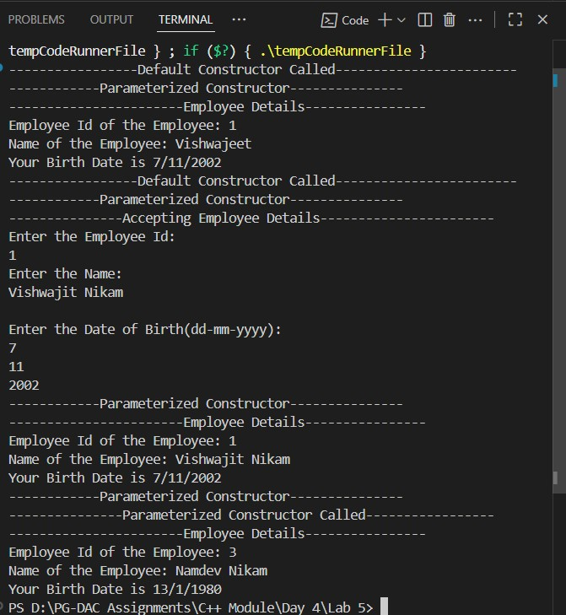
3:Consider that payroll software needs to be developed for computerization of operations of an ABC organization. The organization has employees.
3.1. Construct a class Employee with following members using private access
specifies:
Employee Id integer
Employee Name string
Basic Salary double
HRA double
Medical double=1000
PF double
PT double
Net Salary double
Gross Salary double
Please use following expressions for calculations://Note:Don't accept HRA,PF PT from user
- HRA = 50% of Basic Salary
- PF = 12% of Basic Salary
- PT = Rs. 200

3.2. Write methods to display the details of an employee and calculate the gross and net salary.
- Goss Salary = Basic Salary + HRA + Medical
- Net Salary = Gross Salary – (PT + PF)

Create Object of employee class and assign values and display Details.

#include <iostream> using namespace std;

class Employee { private:
int empId; string empName; double basicSalary; double HRA; double medical = 1000; double PF; double PT = 200; double grossSalary; double netSalary;

public:
void setDetails(int id, string name, double salary) {
empId = id; empName = name;
basicSalary = salary;
HRA = 0.5 * basicSalary; PF = 0.12 * basicSalary; calculateSalary();
}

void calculateSalary() { grossSalary = basicSalary + HRA + medical; netSalary = grossSalary - (PF + PT);
}

void displayDetails() { cout << "\nEmployee ID: " << empId << endl; cout << "Employee Name: " << empName << endl;
cout << "Basic Salary: Rs. " << basicSalary << endl; cout << "HRA: Rs. " << HRA << endl; cout << "Medical: Rs. " << medical << endl; cout << "PF: Rs. " << PF << endl; cout << "PT: Rs. " << PT << endl;
cout << "Gross Salary: Rs. " << grossSalary << endl; cout << "Net Salary: Rs. " << netSalary << endl;
}
};

int main() { Employee emp;
int id;
string name; double salary;

cout << "Enter Employee ID: ";
cin >> id;
cin.ignore(); // To ignore leftover newline cout << "Enter Employee Name: "; getline(cin, name); cout << "Enter Basic Salary: "; cin >> salary;

emp.setDetails(id, name, salary); emp.displayDetails();

return 0;
}

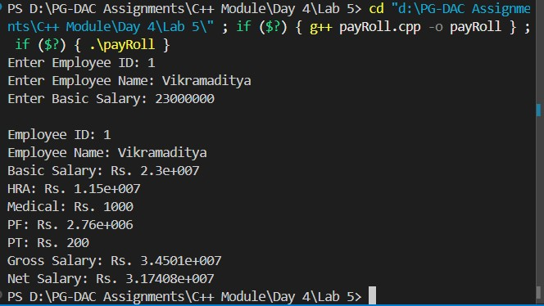

Lab 6

- Solve this.
Fresh business scenario to apply inheritance , polymorphism to emp based organization scenario.

Create Emp based organization structure --- Emp , Mgr , Worker

  - Emp state--- id(int), name, deptId , basicSalary(double)
Accept all of above in constructor arguments.

Methods ---
  - compute net salary ---ret 0
(eg : public double computeNetSalary(){return 0;})

1.2 Mgr state ---id,name,basic,deptId , perfBonus
Add suitable constructor
Methods ----
- compute net salary (formula: basic+perfBonus) -- override computeNetSalary

1.3 Worker state --id,name,basic,deptId,hoursWorked,hourlyRate
Methods :
- compute net salary (formula: = basic+(hoursWorked*hourlyRate) --override computeNetSalary
- get hrlyRate of the worker -- add a new method to return hourly rate of a worker.(getter)

Create suitable array to store organization details.
Provide following options
- Hire Manager
I/P : all manager details

- Hire Worker
I/P : all worker details

- Display information of all employees net salary (by invoking computeNetSal),

- Exit
----------------------------------------------------
#include <bits/stdc++.h> using namespace std;

// ================= Base Employee Class ================= class Employee { private:
int empId; string empName;
int deptId; double basicSalary;

public:
// Constructor
Employee(int empId, string empName, int deptId, double basicSalary)
: empId(empId), empName(empName), deptId(deptId), basicSalary(basicSalary) {}

// Getters int getEmpId() { return empId; } string getEmpName() { return empName; } int getDeptId() { return deptId; }
double getBasicSalary() { return basicSalary; }

// Virtual Function virtual double computeNetSalary() = 0;

// Virtual Destructor (important for cleanup of derived objects) virtual ~Employee() {}
};

// ================= Manager Class ================= class Manager : public Employee { private:
double perfBonus;

public:
Manager(int empId, string empName, int deptId, double basicSalary, double perfBonus)
: Employee(empId, empName, deptId, basicSalary), perfBonus(perfBonus) {}

double computeNetSalary() override { return getBasicSalary() + perfBonus;
}
};

// ================= Worker Class ================= class Worker : public Employee { private:
int hoursWorked; double hourlyRate;

public:
Worker(int empId, string empName, int deptId, double basicSalary, int hoursWorked, double hourlyRate) : Employee(empId, empName, deptId, basicSalary), hoursWorked(hoursWorked), hourlyRate(hourlyRate) {}

double computeNetSalary() override { return getBasicSalary() + (hoursWorked * hourlyRate);
}

double getHourlyRate() { return hourlyRate; }
};

// ================= Main Function =================
int main() {
Employee* employees[100];
int index = 0; int choice;

do { cout << "\n-----------------------Menu---------------------\n"; cout << "1) Hire Manager\n"; cout << "2) Hire Worker\n"; cout << "3) View Employee Details\n"; cout << "4) Exit\n"; cout << "Enter Choice: "; cin >> choice;

if (choice == 1) { int id, dept; string name; double basic, bonus;

cout << "Enter Manager ID: "; cin >> id; cout << "Enter Name: "; cin.ignore(); getline(cin, name); cout << "Enter Department ID: "; cin >> dept; cout << "Enter Basic Salary: "; cin >> basic; cout << "Enter Performance Bonus: "; cin >> bonus;

employees[index++] = new Manager(id, name, dept, basic, bonus);

} else if (choice == 2) { int id, dept, hrs; string name; double basic, rate;

cout << "Enter Worker ID: "; cin >> id; cout << "Enter Name: "; cin.ignore(); getline(cin, name); cout << "Enter Department ID: "; cin >> dept; cout << "Enter Basic Salary: "; cin >> basic;
cout << "Enter Hours Worked: "; cin >> hrs; cout << "Enter Hourly Rate: "; cin >> rate;

employees[index++] = new Worker(id, name, dept, basic, hrs, rate);

} else if (choice == 3) { cout << "\n------ Employee Details ------\n"; for (int i = 0; i < index; i++) { cout << "ID: " << employees[i]->getEmpId()
<< ", Name: " << employees[i]->getEmpName()
<< ", Dept: " << employees[i]->getDeptId()
<< ", Net Salary: " << employees[i]->computeNetSalary()
<< endl;
}
} else if (choice == 4) { cout << "Exiting...\n";
} else { cout << "Invalid choice!\n";
}
} while (choice != 4);

// cleanup for (int i = 0; i < index; i++) { delete employees[i];
}

return 0;
}
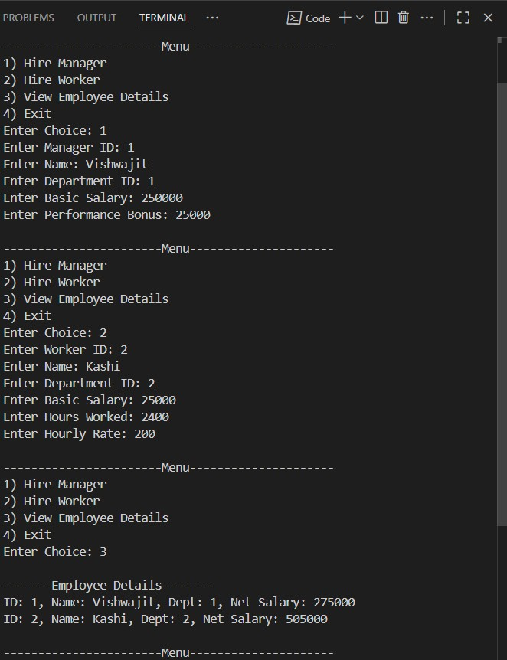

2:Create cpp application for bank account handling.
2.1. Create a class BankAccount -- acct no(int),customer name(string),balance(double)
Add constr. (2 constrs : first to accept all details )

2.2 Add Business logic methods Methods public void withdraw(double amt) public void deposit(double amt)

2.3: Create object of account class and test withdraw and deposit methods.
---------------------------------------------------------------------------------

// Create cpp application for bank account handling.
// 2.1. Create a class BankAccount -- acct no(int),customer name(string),balance(double) // Add constr. (2 constrs : first to accept all details )

// 2.2 Add Business logic methods
// Methods
// public void withdraw(double amt)
// public void deposit(double amt)

// 2.3: Create object of account class and test withdraw and deposit methods.

#include<bits/stdc++.h> #define MAX 100000 using namespace std;

class bankAccount
{ private:
long long accountNumber; string accountHolder; double balance;
double amount;

public: bankAccount()
{
cout<<"---------------Default Constructor Called-------------------"<<endl; this->accountNumber = 7219436696; this->accountHolder = "Mr.Vishwajit Namdev Nikam"; this->balance = 250000;
}

// Parameterized Constructor bankAccount(int accountNumber,string accountHolder,double balance)
{
cout<<"-------------------Parameterized Constructor Called------------------"<<endl; this->accountNumber = accountNumber; this->accountHolder = accountHolder; this->balance =balance;
}

//setter void setBalance()
{
cout<<"Enter the Account Balance: "<<endl; cin>>balance;
}

void setAccountHolderName()
{ cout<<"Enter the name of Account Holder: "<<endl; cin.ignore(); getline(cin,accountHolder);
}

double getBalance()
{ return balance;
}

string getAccountHolderName()
{
return accountHolder;
}

long long getAccountNumber()
{
return accountNumber;
}

//Withdraw Function void withdraw()
{
cout<<"Enter the Amount that you want to Withdraw"<<endl; cin>>amount; if(getBalance() - amount <= 0)
{
cout<<"Insufficient Balance."<<endl;
} else { cout<<amount<<" withdrawed and "<<getBalance() - amount<<" Balance is
remaining."<<endl;
}
}

//Deposit Function void Deposit()
{
cout<<"Enter the amount that you want to deposit: "<<endl; cin>>amount; balance += amount;
}

//Display Function void getBankDetails()
{
cout<<"Account Holder Name: "<<getAccountHolderName()<<endl; cout<<"Account Number: "<<getAccountNumber()<<endl; cout<<"Account Balance: "<<getBalance()<<endl;
} }; int main(int argc, char const *argv[])
{ bankAccount accounts; int choice,index=0;

do{ cout<<"----------Menu---------------"<<endl; cout<<"1) Withdraw "<<endl; cout<<"2) Deposit "<<endl; cout<<"3) Check Bank Details"<<endl; cout<<"4) Exit"<<endl;

cout<<"Enter the choice: "<<endl; cin>>choice; switch(choice)
{ case 1:
cout<<"--------Withdrawl------"<<endl; accounts.withdraw(); break;
case 2:
accounts.Deposit(); cout<<"Deposited."<<endl;
break;
case 3: accounts.getBankDetails(); break;
case 4:
cout<<"Exited..."<<endl; return 0;
default:
cout<<"Enter the Valid Choice"<<endl;
}
}while(choice != 4);

return 0;
}
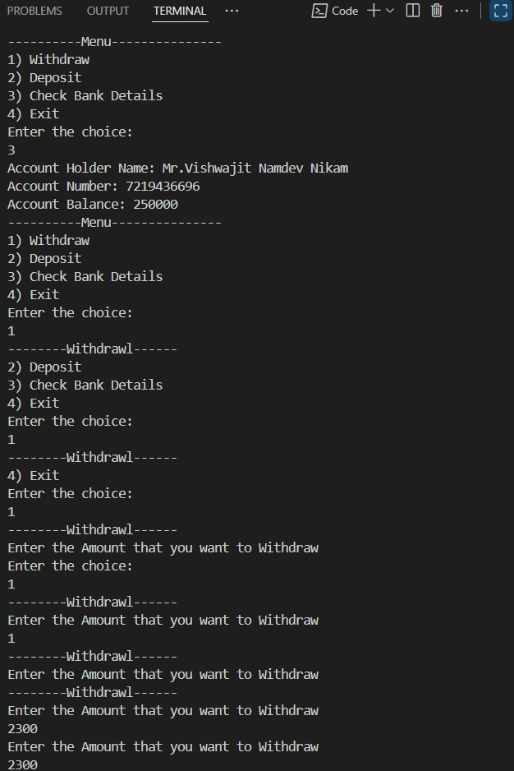

Day 6

Basic Template Assignments
Function Template – Swap
Write a function template swapValues() that swaps two variables of any type.
Test with int, double, and string. #include<bits/stdc++.h> using namespace std;

//Template Function template<class Type>

Type swapValues(Type &m, Type &n)
{
Type temp = m; m = n; n = temp;
}

int main(int argc, char const *argv[])
{ int num1,num2; double num3, num4; string string1,string2;

cout<<fixed<<setprecision<<endl;

cout<<"Enter the value of num1 and num2 (Integer Values): "<<endl; cin>>num1>>num2;

//Integers swapping cout<<"Numbers before swapping: num1= "<<num1<<" num2= "<<num2<<endl; swapValues(num1,num2); cout<<"Numbers after swapping: num1= "<<num1<<" num2= "<<num2<<endl; cout<<fixed<<setprecision<<endl;
//Double swapping cout<<"Enter the value of num1 and num2(double values): "<<endl; cin>>num3>>num4; cout<<"Numbers before swapping: num1= "<<num3<<" num2= "<<num4<<endl; swapValues(num3,num4); cout<<"Numbers after swapping: num1= "<<num3<<" num2= "<<num4<<endl;

//string swapping cout<<fixed<<setprecision<<endl; cout<<"Enter the value of string1 and string2(string Values): "<<endl; cin>>string1>>string2; cout<<"Numbers before swapping: string1= "<<string1<<" string2= "<<string2<<endl; swapValues(string1,string2); cout<<"Numbers after swapping: string1= "<<string1<<" string2= "<<string2<<endl;
return 0;
}
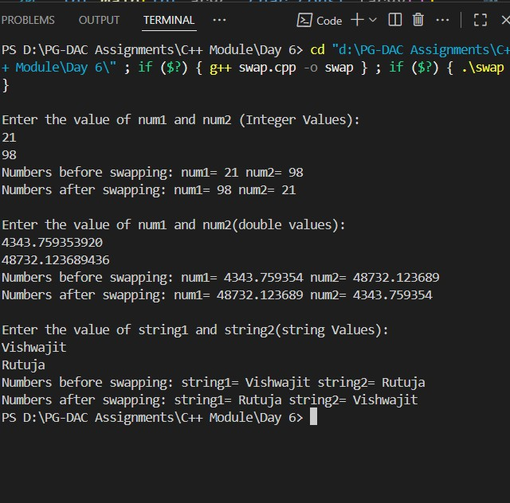
Function Template – Maximum
Write a function template findMax() that returns the maximum of two values.
Test with int, float, and char.
// Function Template – Maximum
// Write a function template findMax() that returns the maximum of two values.

#include<bits/stdc++.h> using namespace std;

template <class Type>

Type findMax(Type &x,Type &y)
{ if(x>=y) return x; else return y;
}

int main(int argc, char const *argv[])
{ int num1,num2;
//Integer Number
//cout<<fixed<<setprecision<<endl; cout<<"Enter two integer numbers: "<<endl; cin>>num1>>num2; cout<<"The max number is "<<findMax(num1,num2)<<endl;
//cout<<fixed<<setprecision<<endl;
//Double double num3,num4; cout<<"Enter two numbers(Double Datatype): "<<endl; cin>>num3>>num4;
//cout<<fixed<<setprecision<<endl; cout<<"largest number is "<<findMax<double>(num3,num4)<<endl;

//Characters char ch1,ch2;
//cout<<fixed<<setprecision<<endl; cout<<"Enter two characters : "<<endl; cin>>ch1>>ch2; cout<<fixed<<setprecision<<endl; cout<<"Lagerst : "<<findMax<char>(ch1,ch2)<<endl;
// cout<<fixed<<setprecision<<endl; return 0;
}
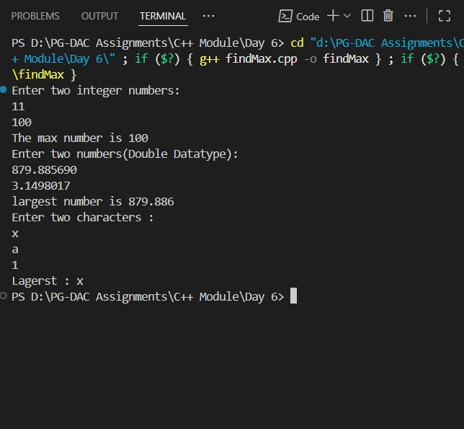

3: Class Template – Box
Implement a class template Box<T> that stores one value of any type and provides getValue() and setValue() methods.
#include <iostream> using namespace std;

template <typename T>
class Box { private:
T value;

public:
// Default Constructor
Box() {}

// Parameterized Constructor
Box(T val)
{ value = val; }
// Setters void setValue(T val)
{ value = val;
}

T getValue()
{ return value;
} }; int main()
{ int num; char ch;
// integer Testing
cout << "Enter the Integers: " << endl; cin >> num; Box<int> b;
b.setValue(num); cout << "Value is: " << b.getValue() << endl;

// character Testing cout << "Enter the character: " << endl; cin >> ch; Box<char> c;
c.setValue(ch); cout << "Value is: " << c.getValue() << endl; return 0;
}
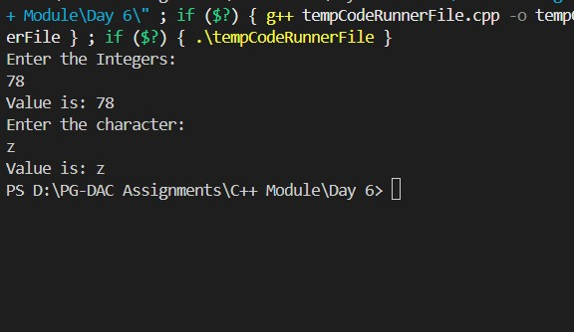

Class Template – Calculator
Create a class template Calculator<T> with functions: add(), subtract(), multiply(), divide().
Test with int and double.
// Class Template – Calculator
// Create a class template Calculator<T> with functions:
// add(), subtract(), multiply(), divide().
// Test with int and double.

#include <iostream> using namespace std;

// Template class template <typename Type>class Calculator
{ private:
Type num1;
Type num2;

public:
// Default Constructor
Calculator() {};

// Parameterized Constructor
Calculator(T val1, T val2)
{ num1 = val1; num1 = val2;
}
// add
Type add(Type val1, Type val2)
{ return val1 + val2; }
// substract
Type sub(Type val1, Type val2)
{ return val1 - val2;
}
// Multiply
Type mult(Type val1, Type val2)
{ return val1 * val2;
}
// Divide
Type div(Type val1, Type val2)
{ return val1 / val2;
}
};

int main() { int num1, num2, choice; double num3, num4;
int option;

do { cout << "--------------------------Menu-------------------------" << endl; cout << "1) Integer Testing" << endl; cout << "2) Double Testing " << endl;
cout << endl;
cout << "Enter the Option: " << endl; cin >> option; switch (option)
{ case 1:
// Integer Testing do
{
cout << "Enter the numbers: " << endl; cin >> num1 >> num2;

cout << endl;

cout << "------------------Menu------------------" << endl; cout << "1) Addition " << endl; cout << "2 Substraction " << endl; cout << "3) Multiplication " << endl; cout << "4) Division " << endl; cout << "5) Exit" << endl;

cout << endl;

cout << "Enter the choice: " << endl; cin >> choice; Calculator <int> A;
switch (choice)
{ case 1:
// Calculator<int>A; cout << "Sum is " << A.add(num1, num2) << endl;
break;
case 2:
// Calculator<int>A; cout << "Substraction is " << A.sub(num1, num2) << endl;
break;
case 3:
// Calculator<int>A; cout << "Multiplication is " << A.mult(num1, num2) << endl;
break;
case 4:
// Calculator<int>A; cout << "Division is " << A.div(num1, num2) << endl;
break; case 5:
cout << "Exiting the Program..." << endl;
return 0; break;
default:
cout << "Enter the Valid Choice..!" << endl;
}
} while (choice != 5); break;
case 2:
// Double Testing do
{ cout << "Enter the numbers: " << endl; cin >> num3 >> num4;

cout << endl;

cout << "------------------Menu------------------" << endl; cout << "1) Addition " << endl; cout << "2 Substraction " << endl; cout << "3) Multiplication " << endl; cout << "4) Division " << endl;

cout << endl;

cout << "Enter the choice: " << endl; cin >> choice;

Calculator<double> B;

switch (choice)
{ case 1:
// Calculator<int>A; cout << "Sum is " << B.add(num3, num4) << endl;
break;
case 2:
// Calculator<int>A; cout << "Substraction is " << B.sub(num3, num4) << endl;
break;
case 3:
// Calculator<int>A; cout << "Multiplication is " << B.mult(num3, num4) << endl;
break;
case 4:
// Calculator<int>A; cout << "Division is " << B.div(num3, num4) << endl;
break; case 5:
cout << "Exiting the Program..." << endl;
return 0; break;
default:
cout << "Enter the Valid Choice..!" << endl;
}
} while (choice != 5); break;

case 3:
cout << "Exit Operation..!" << endl; return 0; break;
default:
cout << "Enter valid Option..." << endl;
}
} while (option != 3); return 0;
}
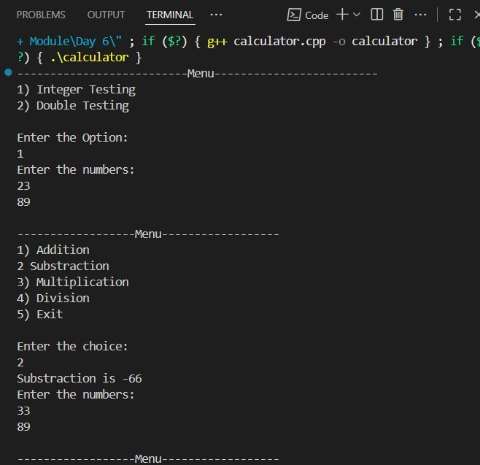

Function Template – Array Sum
Write a function template sumArray() that accepts an array of any type and returns the sum of its elements.
#include <bits/stdc++.h> #define MAX 1000 using namespace std;

// Function Template template<typename T>
T arraySum(T arr[], int size)
{ T sum = 0; for (int i = 0; i < size; i++)
{ sum += arr[i];
}
return sum;
}

int main() { int size; int arr[MAX];

cout << "Enter the size of an Array: " << endl; cin >> size;

cout << "Enter the elements in Array: " << endl; for (int i = 0; i < size; i++)
{ cin >> arr[i];
}

cout << "Your Array: " << endl; for (int i = 0; i < size; i++)
{ cout << arr[i] << " ";
}
cout << endl;

cout << "Sum of the Array is: " << arraySum(arr, size) << endl;

return 0;
}

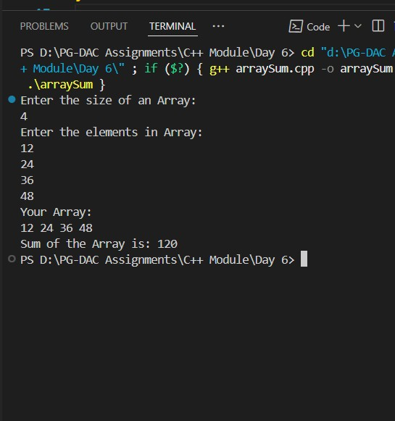

6: Class Template – Stack
Implement a class template Stack<T> with functions: push(), pop(), peek(), isEmpty().Test with int and string.
#include <bits/stdc++.h> #define MAX 1000 using namespace std;

template <typename T> class myStack { private:
T arr[MAX];
int top;

public: myStack() {
top = -1;
}

void push(T value) { if (top >= MAX - 1) { cout << "Stack Overflow..." << endl;
} else { arr[++top] = value;
}
}

T pop() { if (top < 0) { cout << "Stack Underflow..." << endl; return T(); // return default value
} else { return arr[top--];
}
}

T peek() { if (top < 0) { cout << "Stack is Empty..." << endl; return T();
} else {
return arr[top];
}
}

bool isEmpty() { return (top < 0);
}

void Display() { cout << "Your Stack: " << endl; for (int i = top; i >= 0; i--) { cout << arr[i] << endl;
}
}
};

int main() { myStack<int> s1; s1.push(10); s1.push(20); s1.push(30); s1.Display(); cout << "Popped: " << s1.pop() << endl; cout << "Top Element: " << s1.peek() << endl;

myStack<string> s2; s2.push("Hello"); s2.push("World"); s2.Display(); cout << "Popped: " << s2.pop() << endl; return 0;
}

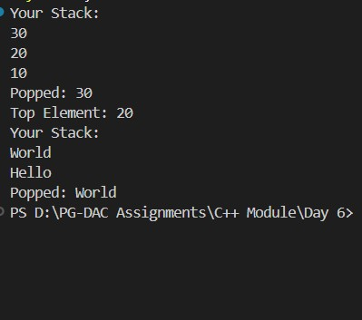

7Class Template – Queue
Implement a class template Queue<T> with functions: enqueue(), dequeue(), front(), isEmpty().

#include <iostream> using namespace std;

template <class T> class Queue { private: int frontIndex, rearIndex, capacity;
T* arr;
public:
Queue(int size = 10) { capacity = size; arr = new T[capacity]; frontIndex = -1; rearIndex = -1;
}

~Queue() {
delete[] arr;
}

bool isEmpty() { return (frontIndex == -1 || frontIndex > rearIndex);
}

bool isFull() { return (rearIndex == capacity - 1);
}

void enqueue(T data) {
if (isFull()) { cout << "Queue is full!" << endl;
return;
}
if (frontIndex == -1) frontIndex = 0; arr[++rearIndex] = data;
}

void dequeue() {
if (isEmpty()) { cout << "Queue is empty!" << endl;
return;
}
cout << "Dequeued: " << arr[frontIndex++] << endl;
}

T front() { if (isEmpty()) { throw runtime_error("Queue is empty!");
}
return arr[frontIndex];
}
};

int main() {
Queue<int> q(5);

q.enqueue(10);
q.enqueue(20);
q.enqueue(30);

cout << "Front element: " << q.front() << endl;

q.dequeue();
q.dequeue();

cout << "Front element: " << q.front() << endl;

q.dequeue();
q.dequeue(); // extra dequeue to test empty case

return 0;
}

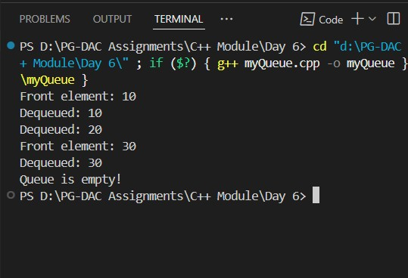

Day 7 Lab

Assignments on STL and File IO

1:Create an application for storing int values in vector.
Create menu drivin app for following menu;
1:add 2:show all 3:search 4:sort 5:reverse 6:clear

#include <bits/stdc++.h>
using namespace std;

int main() {
vector<int> v;
int choice, val;

do {
cout << "\n\t\t------------------ Menu ------------------\n";
cout << "\t\t 1) Add\n";
cout << "\t\t 2) Show all\n";
cout << "\t\t 3) Search\n";
cout << "\t\t 4) Sort\n";
cout << "\t\t 5) Reverse\n";
cout << "\t\t 6) Clear\n";
cout << "\t\t 0) Exit\n";
cout << "------------------------------------------\n";

cout << "Enter your choice: ";
cin >> choice;

switch (choice) {
case 1: {
cout << "Enter the element: ";
cin >> val;
v.push_back(val);
cout << "Element added!\n";
break;
}
case 2: {
if (v.empty()) {
cout << "Vector is empty.\n";
} else {
cout << "Your Vector: ";
for (int num : v) cout << num << " ";
cout << "\n";
}
break;
}
case 3: {
if (v.empty()) {
cout << "Vector is empty.\n";
} else {
int s;
cout << "Enter the element to search: ";
cin >> s;
auto it = find(v.begin(), v.end(), s);
if (it != v.end())
cout << "Element found at position " << (it - v.begin()) << "\n";
else
cout << "Element not found!\n";
}
break;
}
case 4: {
sort(v.begin(), v.end());
cout << "Vector sorted!\n";
break;
}
case 5: {
reverse(v.begin(), v.end());
cout << "Vector reversed!\n";
break;
}
case 6: {
v.clear();
cout << "Vector cleared!\n";
break;
}
case 0:
cout << "Exiting program...\n";
break;
default:
cout << "Invalid choice! Please try again.\n";
}

} while (choice != 0);

return 0;
}
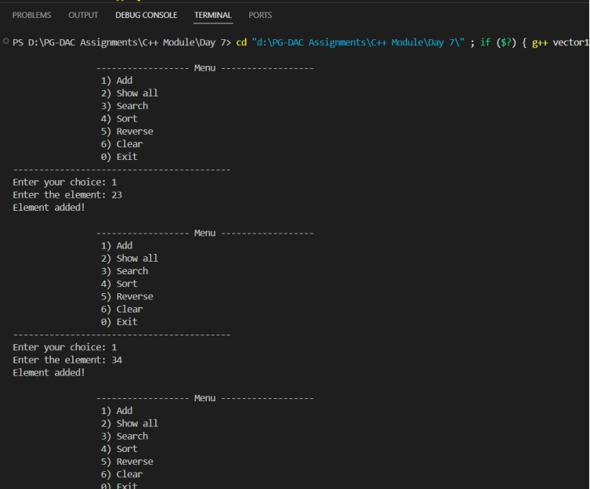
2:Create an application for storing user information in vector.
(Hint:User class with data member userid,name,email,pwd)
Create Menu Driven app
1:add user
2:display all users
3:search user
4:change pwd
5:delete all
#include <bits/stdc++.h>
using namespace std;

class User {
int userid;
string name, email, pwd;

public:
User() {} // default constructor

User(int id, string n, string e, string p) {
userid = id;
name = n;
email = e;
pwd = p;
}

void setData() {
cout << "Enter ID: ";
cin >> userid;
cout << "Enter Name: ";
cin >> name;
cout << "Enter Email: ";
cin >> email;
cout << "Enter Password: ";
cin >> pwd;
}

int getId() const { return userid; }
string getName() const { return name; }
string getEmail() const { return email; }
string getPwd() const { return pwd; }
void setPwd(string p) { pwd = p; }

void display() const {
cout <<" User Id: "<< userid <<endl;
cout<<" Name: " << name<<endl;
cout<<" Email: " << email << endl;
cout<<fixed<<endl;
}
};

int main() {
vector<User> users;
int choice;

do {
cout << "\n1:Add User\n2:Display All Users\n3:Search User\n4:Change Password\n5:Delete All\n6:Exit\nEnter choice: ";
cin >> choice;

switch (choice) {
case 1: {
User u;
u.setData();
users.push_back(u);
break;
}
case 2: {
cout<<"------------User Details---------------"<<endl;
cout<<fixed<<endl;
if (users.empty()) cout << "No users found\n";
else {
for (int i = 0; i < users.size(); i++) {
users[i].display();
}
}
break;
}
case 3: {
int id, found = 0;
cout << "Enter ID to search: ";
cin >> id;
for (int i = 0; i < users.size(); i++) {
if (users[i].getId() == id) {
users[i].display();
found = 1;
break;
}
}
if (!found) cout << "User not found\n";
break;
}
case 4: {
int id, found = 0;
cout << "Enter ID to change password: ";
cin >> id;
for (int i = 0; i < users.size(); i++) {
if (users[i].getId() == id) {
string newpwd;
cout << "Enter new password: ";
cin >> newpwd;
users[i].setPwd(newpwd);
cout << "Password updated\n";
found = 1;
break;
}
}
if (!found) cout << "User not found\n";
break;
}
case 5: {
users.clear();
cout << "All users deleted\n";
break;
}
case 6:
cout << "Exiting...\n";
break;
default:
cout << "Invalid choice\n";
}
} while (choice != 6);

return 0;
}

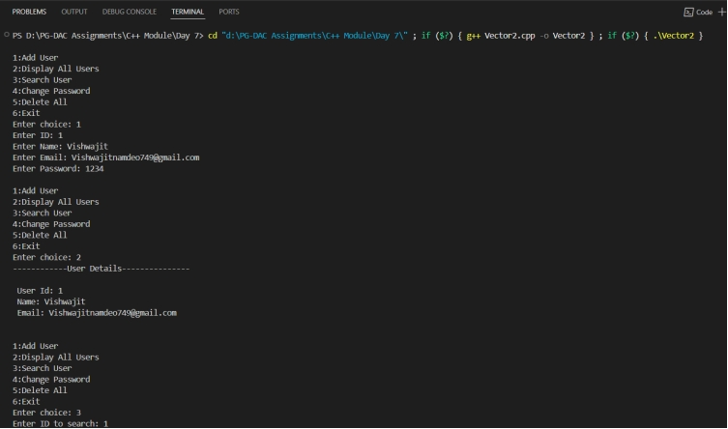
3:Create an application using set .
Accept name of city from user and store in set
Create Menu drivien app
1:add city
2:display all city
3: serach city
#include <bits/stdc++.h>
using namespace std;

int main() {
set<string> cities;
int choice;

do {
cout<<"-----------------Menu------------------"<<endl;
cout<<fixed<<endl;
cout << "\n1:Add City\n2:Display All Cities\n3:Search City\n4:Exit"<<endl;
cout<<fixed<<endl;
cout<<" Enter choice: "<<endl;
cin >> choice;

switch (choice) {
case 1: {
string city;
cout << "Enter city name: ";
cin >> city;
auto result = cities.insert(city);
if (!result.second)
cout << "City already exists\n";
else
cout << "City added\n";
break;
}
case 2: {
if (cities.empty())
cout << "No cities stored\n";
else {
cout <<"----Cities--------"<<endl;
cout<<fixed<<endl;
for (auto &c : cities)
cout << c << endl;
}
break;
}
case 3: {
string city;
cout<<fixed<<endl;
cout << "Enter city name to search: ";
cin >> city;
if (cities.find(city) != cities.end())
cout << "City found: " << city << endl;
else
cout << "City not found\n";
break;
}
case 4:
cout << "Exiting...\n";
break;
default:
cout << "Invalid choice\n";
}
} while (choice != 4);

return 0;
}

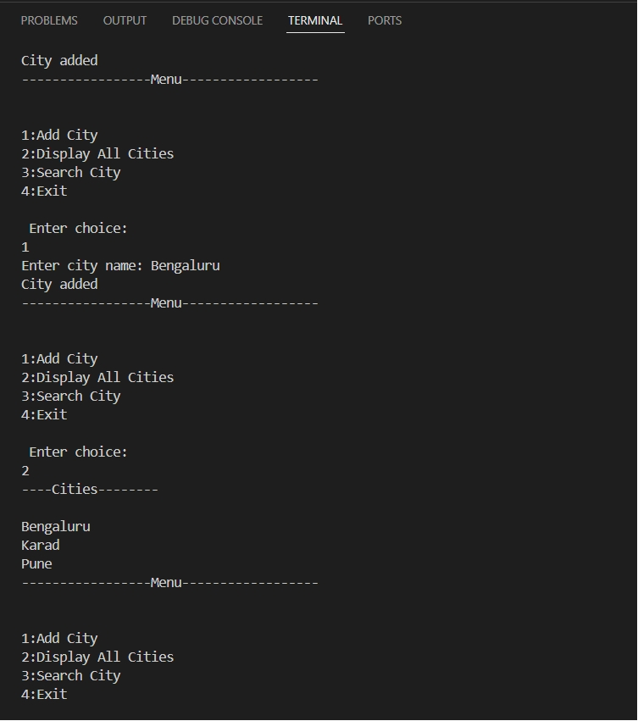
4:Create an application using map for storing key and value
key:int
value:Account type
Create Account class with actid ,name,balance
Create Menu driven app
1:Add Account
2:Display all
3:Search account by actid;
4:Remove all
#include <iostream>
#include <map>
#include <string>
using namespace std;

class Account {
int actid;
string name;
double balance;

public:
Account() {}
Account(int id, string n, double b) {
actid = id;
name = n;
balance = b;
}

int getId() const { return actid; }
string getName() const { return name; }
double getBalance() const { return balance; }

void display() const {
cout << "Account ID: " << actid << " Name: " << name << " Balance: " << balance << endl;
}
};

int main() {
map<int, Account> accounts;
int choice;

do {
cout << "\n1:Add Account\n2:Display All\n3:Search Account by ID\n4:Remove All\n5:Exit\nEnter choice: ";
cin >> choice;

switch (choice) {
case 1: {
int id;
string name;
double bal;
cout << "Enter Account ID: ";
cin >> id;
cout << "Enter Name: ";
cin >> name;
cout << "Enter Balance: ";
cin >> bal;

if (accounts.find(id) != accounts.end()) {
cout << "Account ID already exists!\n";
} else {
accounts[id] = Account(id, name, bal);
cout << "Account added successfully!\n";
}
break;
}
case 2: {
if (accounts.empty())
cout << "No accounts available\n";
else {
cout << "Accounts List:\n";
for (auto &entry : accounts) {
cout << "Key: " << entry.first << " -> ";
entry.second.display();
}
}
break;
}
case 3: {
int id;
cout << "Enter Account ID to search: ";
cin >> id;
auto it = accounts.find(id);
if (it != accounts.end()) {
cout << "Account found!\n";
it->second.display();
} else {
cout << "Account not found\n";
}
break;
}
case 4: {
accounts.clear();
cout << "All accounts removed\n";
break;
}
case 5:
cout << "Exiting...\n";
break;
default:
cout << "Invalid choice\n";
}
} while (choice != 5);

return 0;
}

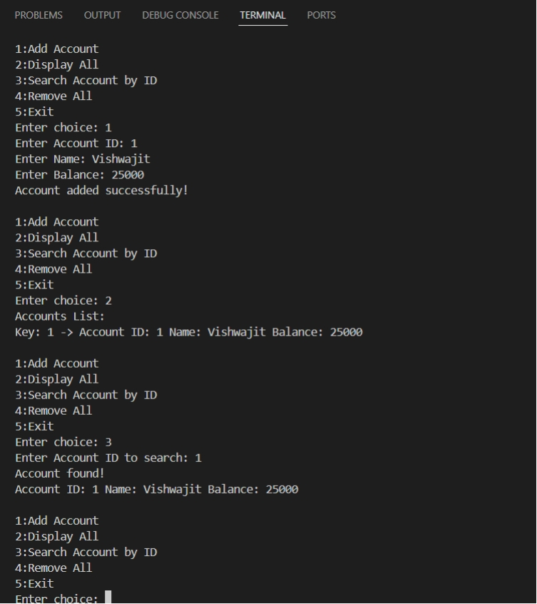

5: Create an File IO application for basic operation
1:Write file:accept data from user and store in file
2:Read file:display line by line
3:copy data from one file into another file
#include <iostream>
#include <fstream>
#include <string>
using namespace std;

int main() {
int choice;
string filename1 = "file1.txt";
string filename2 = "file2.txt";

do {
cout << "\n1:Write File\n2:Read File\n3:Copy Data (file1 → file2)\n4:Exit\nEnter choice: ";
cin >> choice;
cin.ignore(); // clear buffer

switch (choice) {
case 1: {
ofstream fout(filename1, ios::app);
if (!fout) {
cout << "Error opening file for writing\n";
break;
}
string data;
cout << "Enter text (type END to stop):\n";
while (true) {
getline(cin, data);
if (data == "END") break;
fout << data << endl;
}
fout.close();
cout << "Data written successfully!\n";
break;
}
case 2: {
ifstream fin(filename1);
if (!fin) {
cout << "Error opening file for reading\n";
break;
}
string line;
cout << "File Contents:\n";
while (getline(fin, line)) {
cout << line << endl;
}
fin.close();
break;
}
case 3: {
ifstream fin(filename1);
ofstream fout(filename2);
if (!fin || !fout) {
cout << "Error opening file(s)\n";
break;
}
string line;
while (getline(fin, line)) {
fout << line << endl;
}
fin.close();
fout.close();
cout << "Data copied from " << filename1 << " to " << filename2 << " successfully!\n";
break;
}
case 4:
cout << "Exiting...\n";
break;
default:
cout << "Invalid choice\n";
}
} while (choice != 4);

return 0;
}

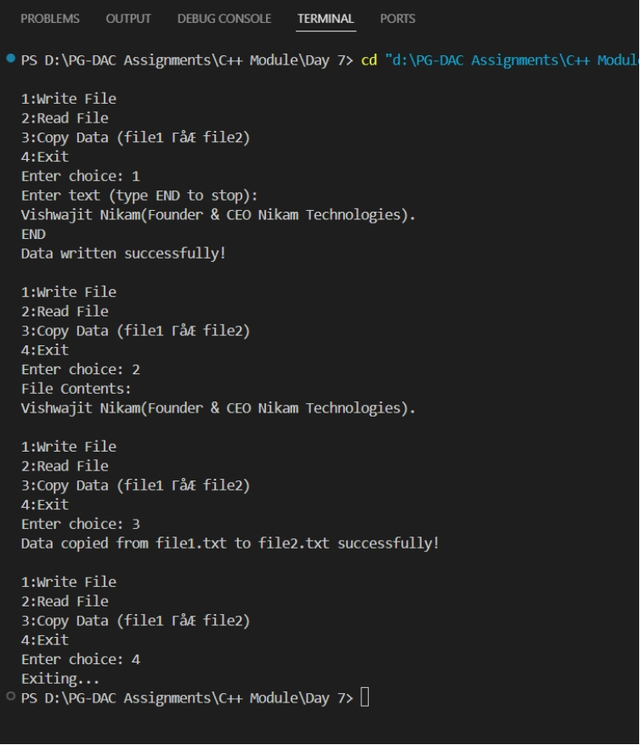
6: Create CRUD Shop Application Using File
Write class Product with data member prdid,name,qty,price;
Menus:
1:Add Prd
2:Display Prds
3:Search Prd
4:Update/Modify prd
5:delete prd

#include <iostream>
#include <fstream>
#include <string>
#include <cstring> // for strcpy
using namespace std;

class Product {
int prdid;
char name[50]; // fixed-size array for safe file storage
int qty;
double price;

public:
Product() {}
Product(int id, const char* n, int q, double p) {
prdid = id;
strcpy(name, n);
qty = q;
price = p;
}

int getId() const { return prdid; }
const char* getName() const { return name; }
int getQty() const { return qty; }
double getPrice() const { return price; }

void setData() {
cout << "Enter Product ID: ";
cin >> prdid;
cout << "Enter Name: ";
cin.ignore(); // clear leftover newline
cin.getline(name, 50);
cout << "Enter Quantity: ";
cin >> qty;
cout << "Enter Price: ";
cin >> price;
}

void display() const {
cout << "ID: " << prdid
<< " | Name: " << name
<< " | Qty: " << qty
<< " | Price: " << price << endl;
}
};

// File name
const string FILENAME = "products.dat";

// Add product
void addProduct() {
Product p;
p.setData();
ofstream fout(FILENAME, ios::binary | ios::app);
fout.write((char*)&p, sizeof(p));
fout.close();
cout << "✅ Product added successfully!\n";
}

// Display all products
void displayProducts() {
ifstream fin(FILENAME, ios::binary);
if (!fin) {
cout << "⚠️ No products found!\n";
return;
}
Product p;
cout << "\n--- Product List ---\n";
while (fin.read((char*)&p, sizeof(p))) {
p.display();
}
fin.close();
}

// Search product by ID
void searchProduct() {
ifstream fin(FILENAME, ios::binary);
if (!fin) {
cout << "⚠️ File not found!\n";
return;
}
int id, found = 0;
cout << "Enter product ID to search: ";
cin >> id;
Product p;
while (fin.read((char*)&p, sizeof(p))) {
if (p.getId() == id) {
cout << " Product found!\n";
p.display();
found = 1;
break;
}
}
if (!found) cout << " Product not found!\n";
fin.close();
}

// Update product
void updateProduct() {
fstream file(FILENAME, ios::binary | ios::in | ios::out);
if (!file) {
cout << " File not found!\n";
return;
}
int id, found = 0;
cout << "Enter product ID to update: ";
cin >> id;
Product p;
while (file.read((char*)&p, sizeof(p))) {
if (p.getId() == id) {
cout << "Current details:\n";
p.display();
cout << "Enter new details:\n";
Product newP;
newP.setData();
file.seekp(-sizeof(p), ios::cur);
file.write((char*)&newP, sizeof(newP));
cout << " Product updated!\n";
found = 1;
break;
}
}
if (!found) cout << " Product not found!\n";
file.close();
}

// Delete product
void deleteProduct() {
ifstream fin(FILENAME, ios::binary);
if (!fin) {
cout << " File not found!\n";
return;
}
ofstream fout("temp.dat", ios::binary);
int id, found = 0;
cout << "Enter product ID to delete: ";
cin >> id;
Product p;
while (fin.read((char*)&p, sizeof(p))) {
if (p.getId() == id) {
cout << "🗑️ Deleting product: ";
p.display();
found = 1;
} else {
fout.write((char*)&p, sizeof(p));
}
}
fin.close();
fout.close();
remove(FILENAME.c_str());
rename("temp.dat", FILENAME.c_str());
if (found) cout << " Product deleted!\n";
else cout << " Product not found!\n";
}

int main() {
int choice;
do {
cout << "\n===== Shop Menu =====\n";
cout << "1: Add Product\n";
cout << "2: Display Products\n";
cout << "3: Search Product\n";
cout << "4: Update/Modify Product\n";
cout << "5: Delete Product\n";
cout << "6: Exit\n";
cout << "Enter choice: ";
cin >> choice;

switch (choice) {
case 1: addProduct(); break;
case 2: displayProducts(); break;
case 3: searchProduct(); break;
case 4: updateProduct(); break;
case 5: deleteProduct(); break;
case 6: cout << " Exiting...\n"; break;
default: cout << " Invalid choice!\n";
}
} while (choice != 6);

return 0;
}

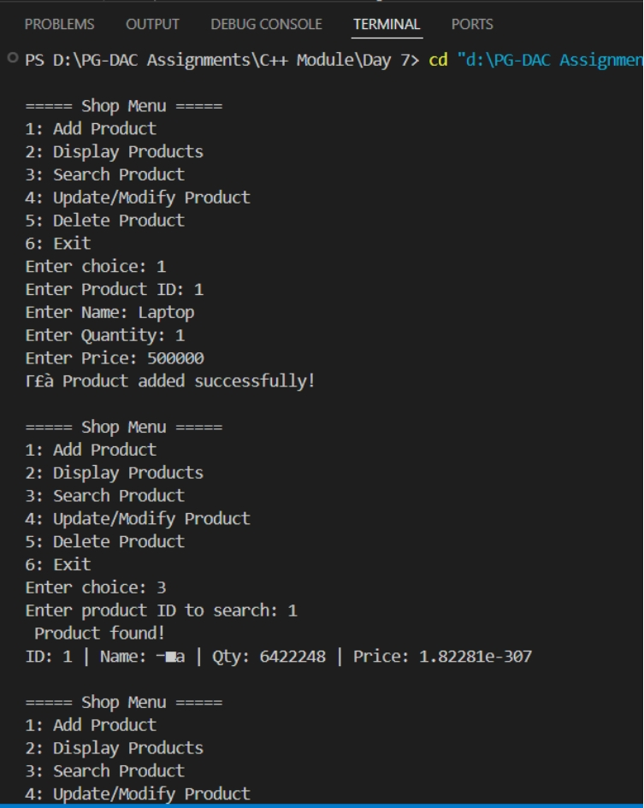

7:Create Student class in namespace CDAC namespace .
Create another Student class in IACSD namespace.
Try to access both student classes using namespace

#include <iostream>
using namespace std;

namespace CDAC {
class Student {
int roll;
string name;
public:
Student(int r, string n) {
roll = r;
name = n;
}
void display() {
cout << "[CDAC] Roll: " << roll << " Name: " << name << endl;
}
};
}

namespace IACSD {
class Student {
int roll;
string name;
public:
Student(int r, string n) {
roll = r;
name = n;
}
void display() {
cout << "[IACSD] Roll: " << roll << " Name: " << name << endl;
}
};
}

int main() {
// Fully qualified names
CDAC::Student s1(101, "Rahul");
IACSD::Student s2(201, "Sneha");

s1.display();
s2.display();

// Using namespace alias
namespace C = CDAC;
namespace I = IACSD;

C::Student s3(102, "Amit");
I::Student s4(202, "Priya");

s3.display();
s4.display();

return 0;
}

